# Spring Certification Module 4 – Spring Boot

# Section 2: Spring Boot Intro

# Question 01 -What is Spring Boot?

Spring Boot is a Java Framework that allows you to easily create stand-alone, production-grade Spring based Java Applications. It is often used in Microservice Architecture because of simplicity that it allows.

Applications created with Spring Boot can be executed with simple java –jar command and also allows traditional war deployment. Spring Boot supports following embedded containers:

* Tomcat
* Jetty
* Undertow

Simplicity of deployment and execution has many advantages, for example, it allows for Dev/Prod parity (https://12factor.net/) which increases product quality.

Spring Boot provides number of features that can be used to fulfill non-functional requirements for the project (externalized configuration, security, metrics, health checks).

Spring Boot provides many modules under common umbrella:

* Spring Boot DevTools–live-reload to speed-up development
* Spring Boot Actuator –monitoring and management of application
* Spring Boot Starters –dependency set for technologies to minimize setup time
* Spring Boot Autoconfiguration –configuration templates for technologies to minimize setup time

On top of it, you can use all Spring Framework technologies, like:

* Spring Web –Spring MVC Framework
* Template Engines –server side rendering engines for web pages
* Spring Security –authentication and authorization framework
* Spring Data MongoDB –NoSQL database client
* ... and many more

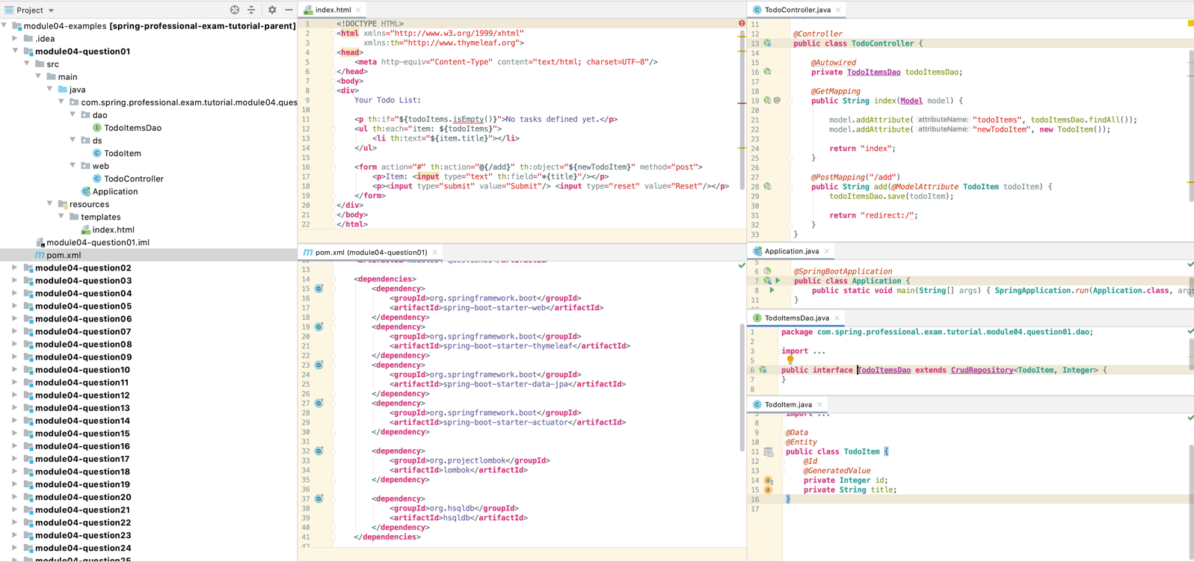

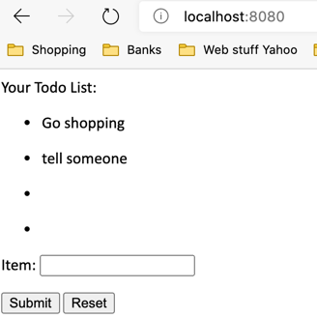

# Question 02-What are the advantages of using Spring Boot?

* Maximizes productivity
* Simplifies deployment, by allowing to create executable jar, and also supports traditional deployment on top of application server
* Provides automatic configuration which reduces boilerplate configuration, and allows easy customization when defaults are not sufficient
* Allows for Dev/Prod Parity (https://12factor.net/)
* Provides set of managed dependencies
* Provides Maven Plugins
* Provides non-functional features common for projects -externalized configuration, security, metrics, health checks
* Integrates with Micro Service Architecture Tools for building Highly Available and Fault Tolerant Applications –Eureka, Ribbon, OpenFeign
* Integrates with systemd and init.d, which allows to easily run applications as Linux Services
* Uses IoC/DI from Spring Framework

## 2.1 Example – same as before but with initialization script and actuator properties changed

### application.properties

**management.endpoints.web.exposure.include**=* //localhost:8080/actuator/mappings or health or beans or env

### import.sql

**insert into** todo_item **values**(1, 'Export Data for HR');  
**insert into** todo_item **values**(2, 'Send report to John');  
**insert into** todo_item **values**(3, 'Specify requirements with PO');  
**insert into** todo_item **values**(4, 'Review budget with PM');

This adds the info straight to the database – nothing in application.properties

## 2.2 Running the jar file on a linux box

1. Copy jar onto server
2. create spring-boot-app.service

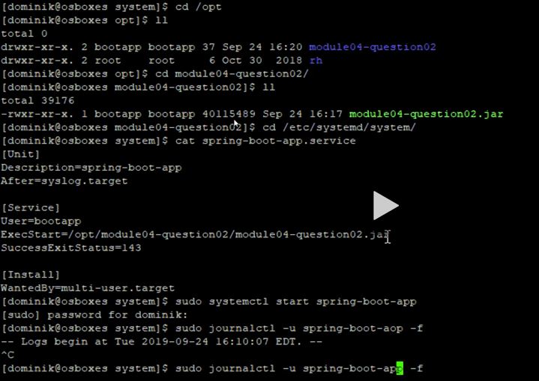

1. sudo systemctl start spring-boot-app
2. sudo journalctl -u spring-boot-app -f

# Question 03-Why is it "opinionated"?

Spring Boot is “opinionated” framework because it comes with general idea on how application should be organized, provides default configurations and modules setups for technology related aspect of application. (embedded databases, mvcview resolvers, template rendering engines, ...)

In comparison with Spring Framework, Spring Boot provides starters and autoconfigurations which intelligently fits default configuration based on defined dependencies.

Main advantage on how Spring Boot approaches “opinionated” style, is that you can always override default configuration if it does not fit your use case.

“Opinionated” has following advantages:

* Simplifies application setup
* Maximizes productivity, by allowing you to focus on business code instead of setup of technology related code
* Allows you to write configuration only in case when defaults are not a good fit for your case
* Allows easy integration with technology modules (Embedded Databases, Containers ...)
* Minimizes amount of setup code

The main disadvantage of “opinionated” framework is that, if your application does not fall into most use cases supported by framework, you will have to override most of default setup, configurations and project organization, which might harm your productivity.

## 3.1 Example

The auto config version is provided in the previous examples. If you want to configure yourself you need to add the following classes…

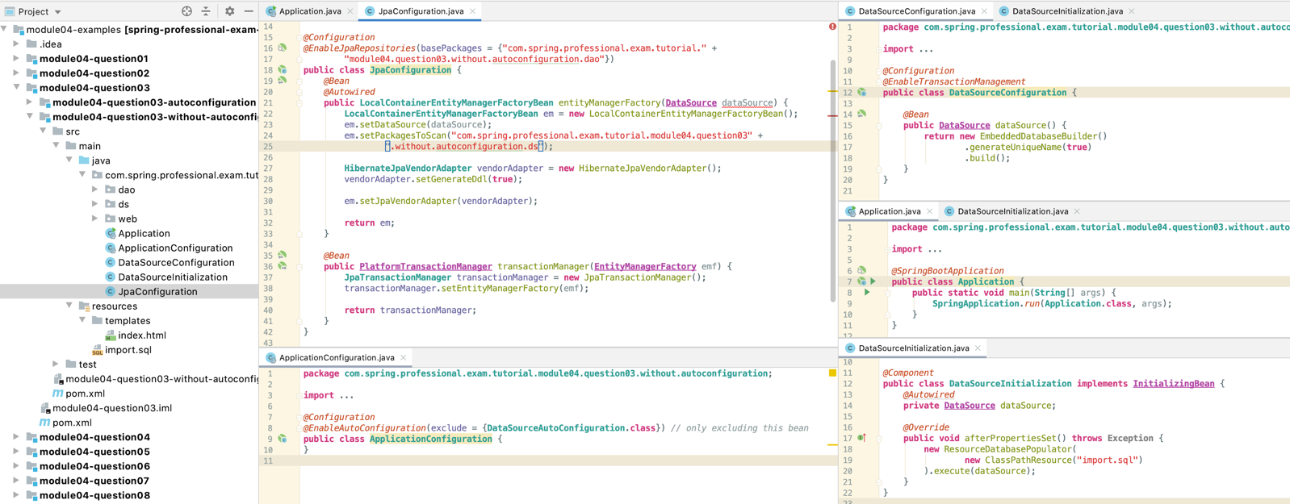

# Question 04-What things affect what Spring Boot sets up?

Spring Boot uses autoconfiguration to detect dependencies on the class path, based on detected dependencies, spring beans are configured to allow integration with technologies, like JPA, Data Sources, Embedded Databases, Template Rendering engines etc.

Spring Boot searches for META-INF/spring.factories on classpath that should contain entry org.springframework.boot.autoconfigure.EnableAutoConfiguration that lists all autoconfiguration classes provided by the autoconfiguration module.

Autoconfiguration class is using @ConditionalOn... annotations to specify under which conditions, certain Autoconfiguration should be applied.

Spring Boot provides starter modules, which are empty jars with set of dependencies specified with correct dependencies versions to allow easy start with the library.

Starter module may provide only set of dependencies, or set of dependencies with autoconfiguration code.

Spring Boot supports following Conditional Annotations for AutoConfiguration classes:

* ConditionalOnBean–presence of Spring Bean
* ConditionalOnMissingBean–absence of Spring Bean
* ConditionalOnClass–presence of class on classpath
* ConditionalOnMissingClass–absence of class on classpath
* ConditionalOnCloudPlatform–if specified cloud platform is active –for example Cloud Foundry
* ConditionalOnExpression–if SpEL expression is true
* ConditionalOnJava–presence of Java in specified version
* ConditionalOnJndi–if JNDI location exists
* ConditionalOnWebApplication–if a web application that uses WebApplicationContext or StandardServletEnvironment
* ConditionalOnNotWebApplication–application that is not a web application
* ConditionalOnProperty–presence of spring property
* ConditionalOnResource–presence of resource
* ConditionalOnSingleCandidate–only one candidate for the bean found

Set up autoconfigure classes in separate module and import it into pom

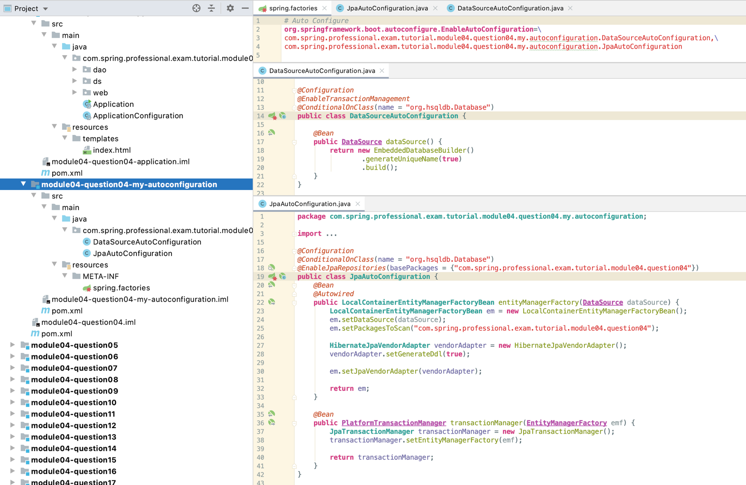

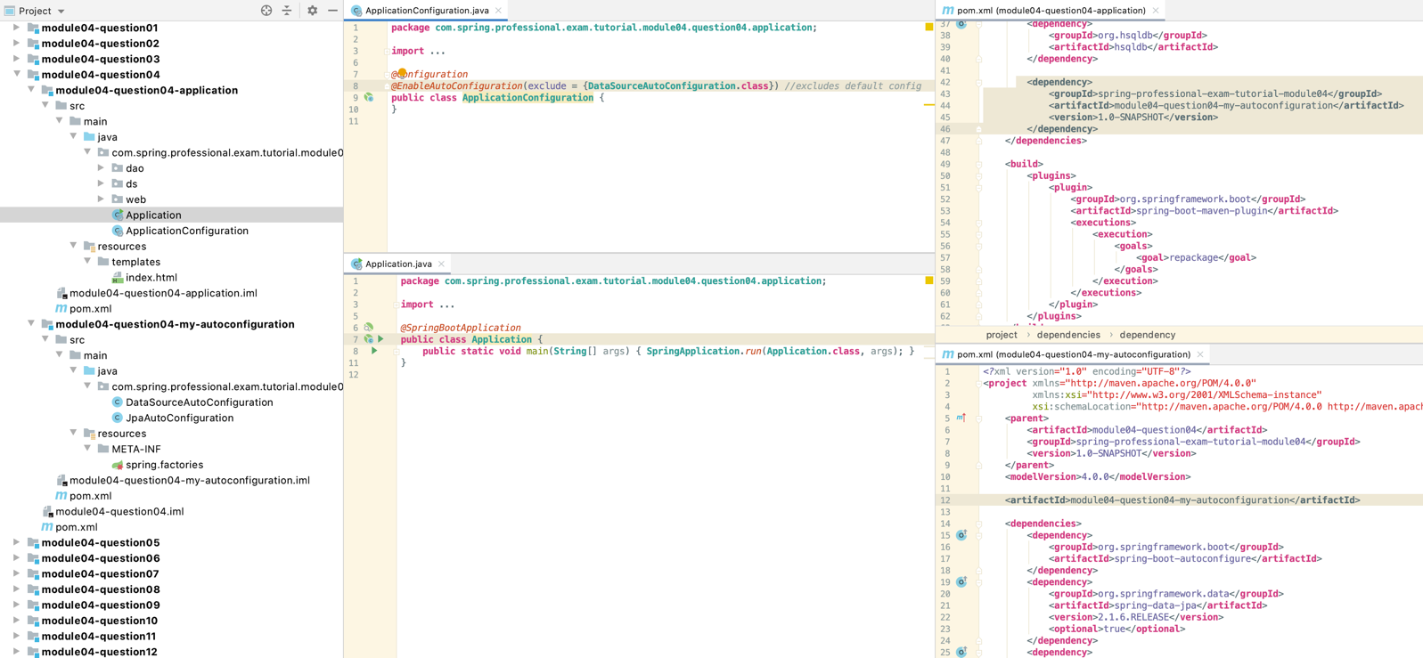

# Question 05-What is a Spring Boot starter POM? Why is it useful?

Spring Starter POM is a maven module that represents empty jar with set of dependencies required to work with specified technology. Spring Starter may also provide autoconfiguration to create beans required to integrate project with technologies that you intend to use.

Spring Starters are useful, because they simplify project setup by assuring that all dependencies in correct versions are set. If Starter provides autoconfiguration as well, it integrates technology with Spring Framework.

This allows you to focus on business code instead of having to spend time on identifying which dependency set is required and which versions are correct. Autoconfiguration allows you to use technology within Spring Framework without having to integrate technology with it manually.

Example below show validator added and used as @NotBlank and validated in the controller.

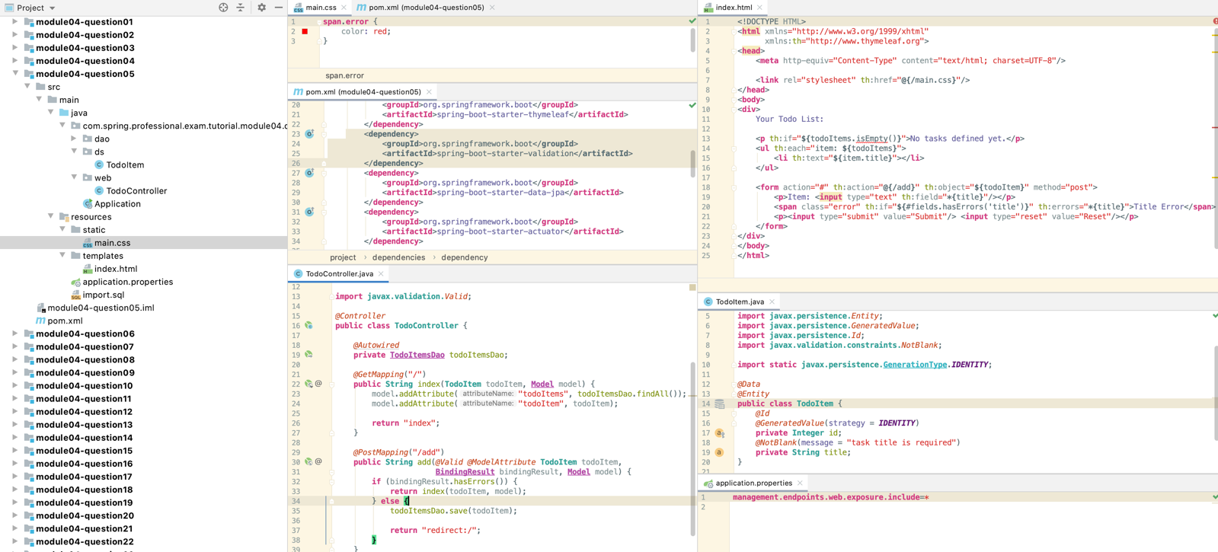

# Question 06-Spring Boot supports both properties and YML files. Would you recognize and understand them if you saw them?

Spring Boot allows you to externalize configuration for the application by using properties stored in properties files that can be in format:

* YAML
* Java Properties File

YAML is a superset of JSON and it is convenience for specifying hierarchical data. Spring Boot supports YAML properties with usage of SnakeYAML library, which is included by default by spring-boot-starter.

You can transform application properties between YAML and Java Properties format:

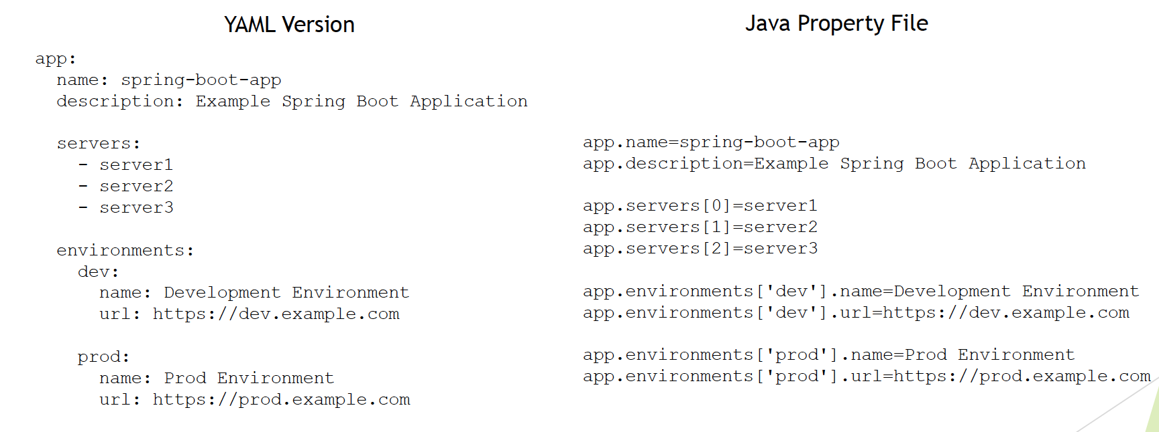

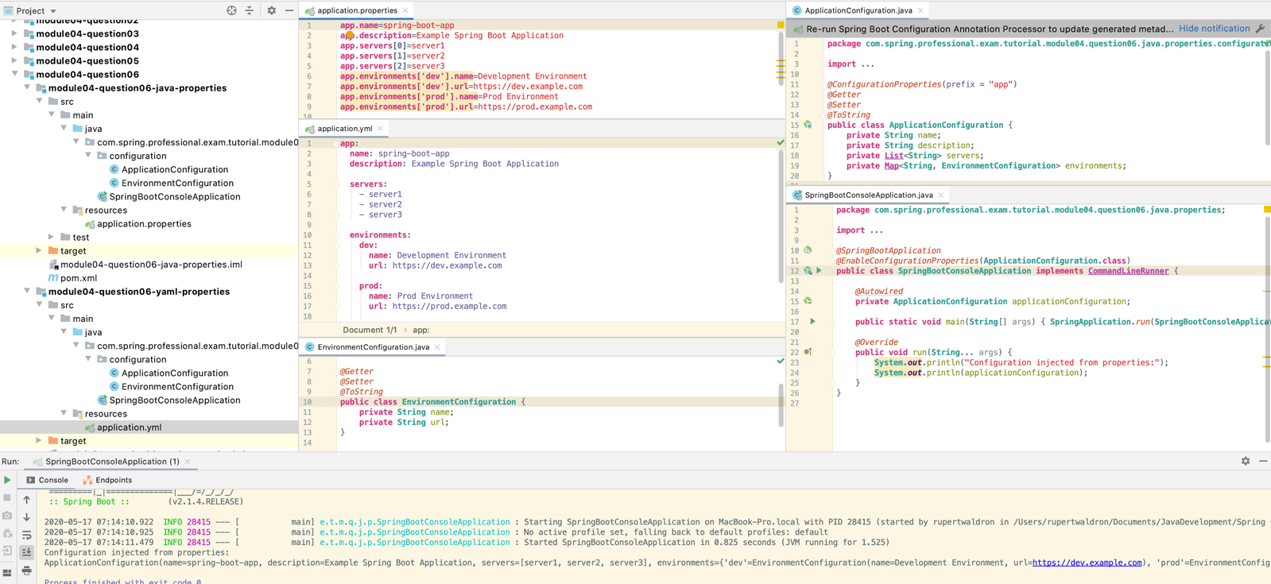

# Question 07-Can you control logging with Spring Boot? How?

Spring Boot allows you to configure following aspects of logging:

* Logging Levels
* Logging Pattern
* Logging Colors
* Logging Output –console, file
* Logging Rotation
* Logging Groups
* Logging System used
* Logback –default
* log4j2
* JDK (Java Util Logging)
* Logging System specific configuration:
* Logback –logback-spring.xml
* log4j2 -log4j2-spring.xml
* JDK (Java Util Logging) -logging.properties

Logging Levels can be set via application.properties:

logging.level.root=WARN

app.service.a.level=ALL

app.service.b.level=FINEST

app.service.c.level=FINER

or by using logging system specific configuration, logback-spring.xml example:

<logger name="app.service.a" level="INFO"/>

<logger name="app.service.b" level="DEBUG"/>

<logger name="app.service.c" level="WARN"/>

You can also use ––debug or ––trace argument when launching spring boot application:

$ java -jar myapp.jar ––debug

It is also possible to specify debug=true or trace=true in application.properties.

Logging patterns can be set via application.properties:

logging.pattern.console=%clr(%d{yy-MM-dd E HH:mm:ss.SSS}) \

{blue} %clr(%-5p) %clr(${PID}){faint} \

%clr(---){faint} %clr([%8.15t]){cyan} \

%clr(%-40.40logger{0}){blue} \

%clr(:){red} %clr(%m){faint}%n

or by using logging system specific configuration, logback-spring.xml example:

<appendername="CONSOLE" class="ch.qos.logback.core.ConsoleAppender">

<encoder>

<pattern>%d{yyyy-MM-dd} | %d{HH:mm:ss.SSS} | %thread | %5p | %logger{25} | %12(ID: %8mdc{id}) | %m%n</pattern>

<charset>utf8</charset>

</encoder>

</appender>

When ANSI support for logging output is enabled, you can use colors to format your logs. Colors are used with %clrword.

Example:

%clr(%d{yyyy-MM-dd HH:mm:ss.SSS}){yellow}

Example usage in logback-spring.xml:

<appendername="2CONSOLE" class="ch.qos.logback.core.ConsoleAppender">

<encoder>

<pattern**>%clr(%thread){red}** | %5p | %logger{25} | %m%n</pattern>

<charset>utf8</charset>

</encoder>

</appender>

Following colors are supported:

* blue
* cyan
* faint
* green
* magenta
* red
* yellow

Spring Boot by default logs only to console. You can change this behaviour via application.propertiesor by using logging system specific configuration.

If you want to change this behavior via application.properties, you need to set one of following property:

logging.file

logging.path

You can also do this via logging system specific configuration, for example logback-spring.xml:

...

<root level="INFO">

<appender-ref ref="CONSOLE"/>

<appender-ref ref="FILE"/>

<appender-ref ref="ROLLING-APPENDER"/>

</root>

Spring Boot allows you to control logs rotation by specifying maximum file size and maximum number of logs file to keep in history.

To achieve this behaviour through application.properties, you need to set following properties:

logging.file.max-size

logging.file.max-history

You can also configure logging system specific settings, for example in logback-spring.xml you can configure rolling appender:

<rollingPolicyclass="ch.qos.logback.core.rolling.SizeAndTimeBasedRollingPolicy">

<fileNamePattern>

${LOG_PATH}/archived/log_%d{dd-MM-yyyy}_%i.log

</fileNamePattern>

<maxFileSize>10MB</maxFileSize>

<maxHistory>10</maxHistory>

<totalSizeCap>100MB</totalSizeCap>

</rollingPolicy>

Spring Boot can group loggers into group, which simplifies log management.

You can do this on application.properties level in following way:

logging.group.service-d-and-e=app.service.d, app.service.e

logging.level.service-d-and-e=DEBUG

Spring Boot allows you to chose between logging subsystem.

To use default Logback, you just need to use spring-boot-starter dependency, autoconfiguration will setup all required beans:

<dependencies>

<dependency>

<groupId>org.springframework.boot</groupId>

<artifactId>spring-boot-starter</artifactId>

</dependency>

</dependencies>

Spring Boot allows you to chose between logging subsystem.

To use log4j2, you just need to exclude spring-boot-starter-logging and add dependency to log4j2:

<dependencies>

<dependency>

<groupId>org.springframework.boot</groupId>

<artifactId>spring-boot-starter</artifactId>

<exclusions>

<exclusion>

<groupId>org.springframework.boot</groupId>

<artifactId>spring-boot-starter-logging</artifactId>

</exclusion>

</exclusions>

</dependency>

<dependency>

<groupId>org.springframework.boot</groupId>

<artifactId>spring-boot-starter-log4j2</artifactId>

</dependency>

</dependencies>

Spring Boot allows you to chose between logging subsystem.

To use JDK (Java Util Logging), you need to exclude spring-boot-starter-logging:

<dependencies>

<dependency>

<groupId>org.springframework.boot</groupId>

<artifactId>spring-boot-starter</artifactId>

<exclusions>

<exclusion>

<groupId>org.springframework.boot</groupId>

<artifactId>spring-boot-starter-logging</artifactId>

</exclusion>

</exclusions>

</dependency>

</dependencies>

Then initialize JDK logging in the code:

LogManager.getLogManager().readConfiguration(

SpringBootConsoleApplication.class.getResourceAsStream("/logging.properties")

);

## 7.1 Logback

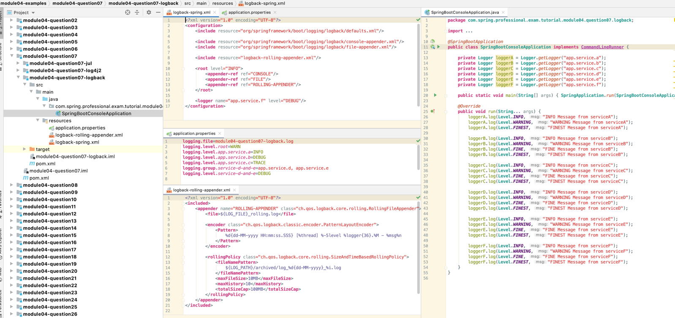

## 7.2 log4j2

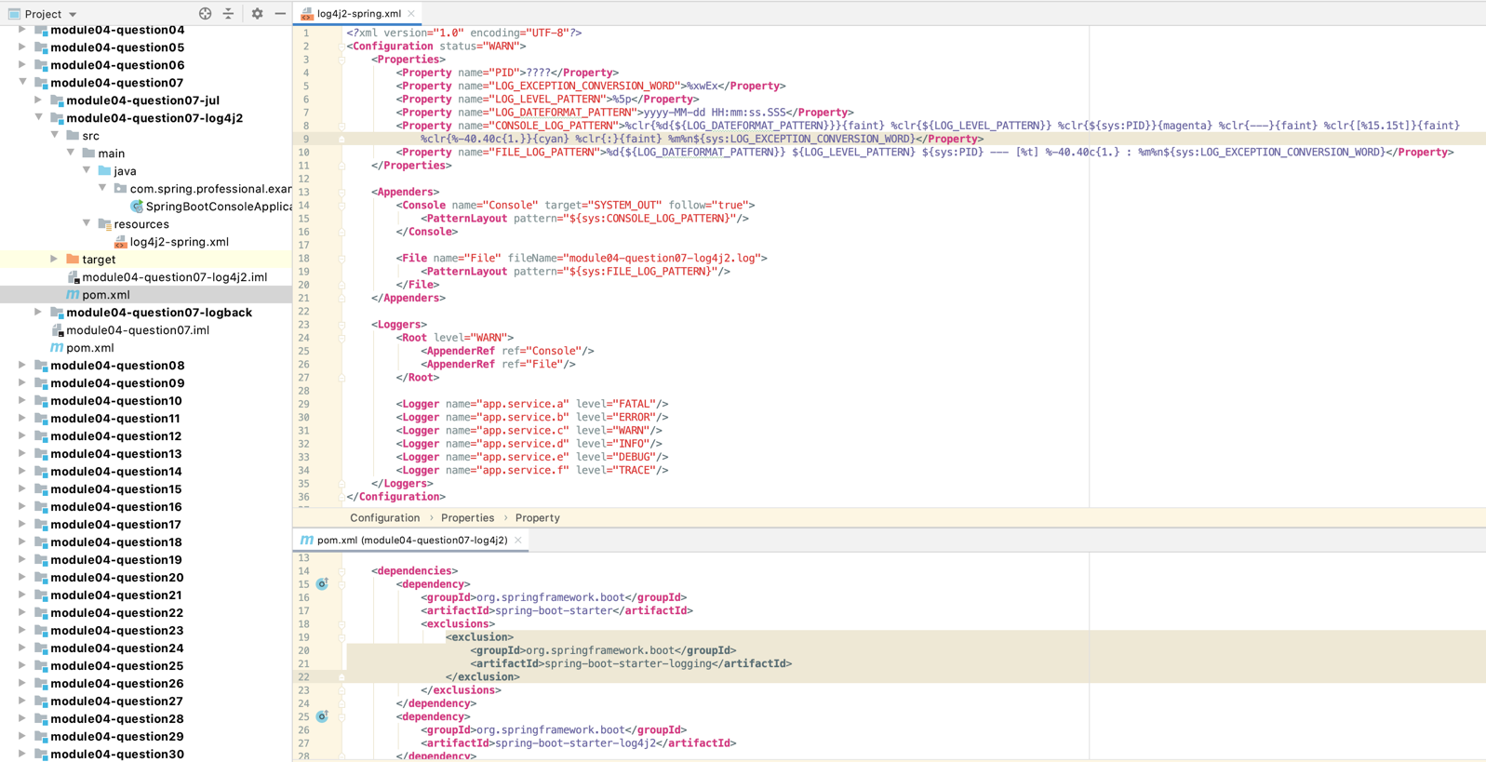

## 7.3 Java Util Logging

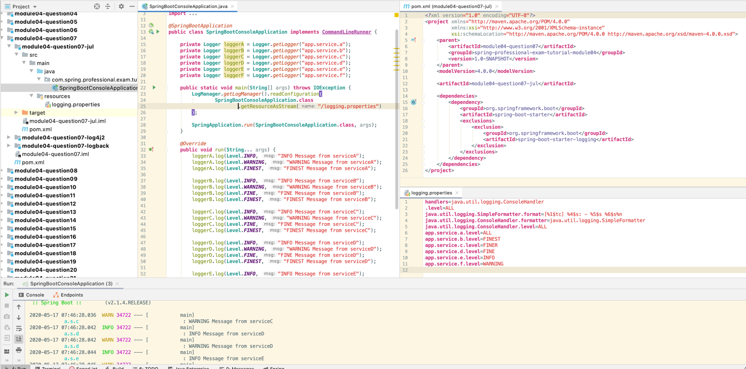

# Question 08-Where does Spring Boot look for property file by default?

Spring Boot looks for properties in following locations:

* Profile Specific:
  + Outside of Jar:
    - application-{profile}.properties and application-{profile}.yml outside of jar in /config subdirectory
    - application-{profile}.properties and application-{profile}.yml outside of jar in current directory
  + Inside Jar:
    - application-{profile}.properties and application-{profile}.yml inside of jar in /config package on classpath
    - application-{profile}.properties and application-{profile}.yml inside of jar in classpath root package
* Application Specific:
  + Outside of Jar:
    - application.properties and application.yml outside of jar in /config subdirectory
    - application.properties and application.yml outside of jar in current directory
  + Inside Jar:
    - application.properties and application.yml inside of jar in /config package on classpath
    - application.properties and application.yml inside of jar in classpath root package

You can change name of default configuration file with usage of spring.config.name property:

$ java -jar myproject.jar --spring.config.name=myproject

You can also explicitly point location of configuration file with usage of spring.config.location property:

$ java -jar myproject.jar --spring.config.location=classpath:/default.properties

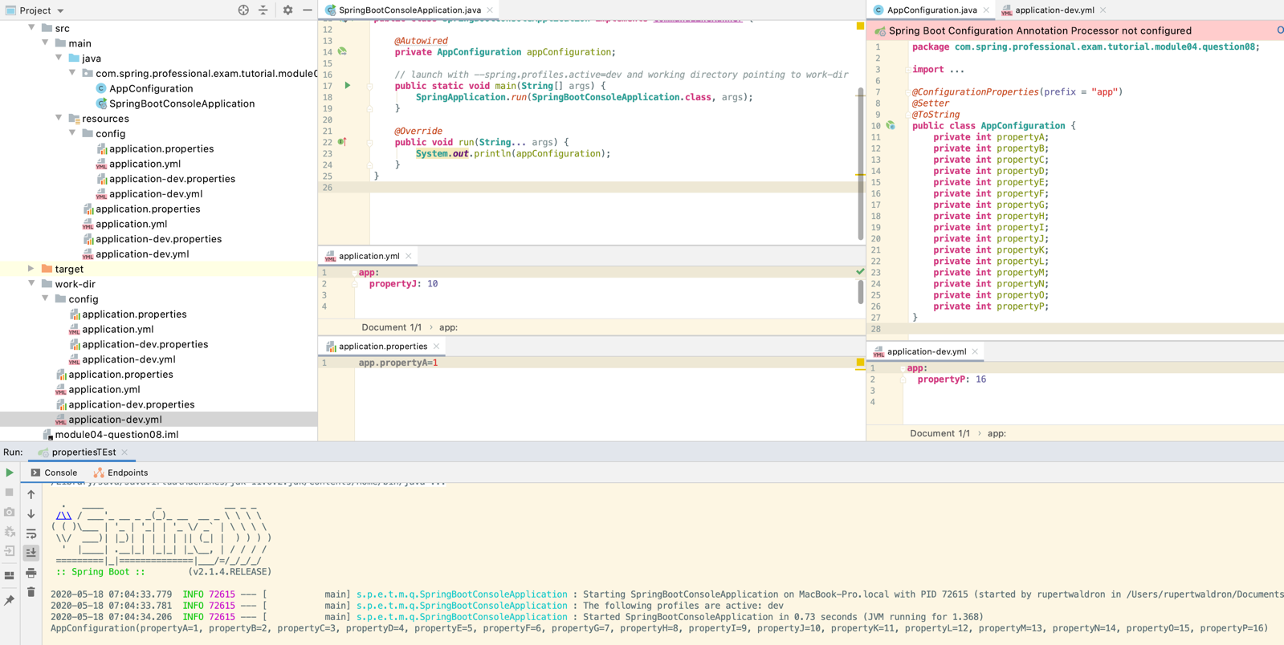

*@SpringBootApplication  
@EnableConfigurationProperties*(**AppConfiguration**.**class**)  
**public class SpringBootConsoleApplication implements CommandLineRunner** {  
  
 *@Autowired* **private AppConfiguration** appConfiguration;  
  
 *// launch with --spring.profiles.active=dev and working directory pointing to work-dir* **public static void** main(**String**[] args) {  
 **SpringApplication**.*run*(**SpringBootConsoleApplication**.**class**, args);  
 }  
  
 *@Override* **public void** run(**String**... args) {  
 **System**.***out***.println(appConfiguration);  
 }  
}

# Question 09-How do you define profile specific property files?

Spring Boot allows you to define profile specific property files in two ways:

* Dedicated property file per profile:
  + application-{profile}.properties
  + application-{profile}.yml
    - You can also use application-default.propertiesor application-default.ymlfilename to specify property file that should be used when no profile is set
* Multi-profile YAML Document

server:

url: https://local.service.com/

---

spring:

profiles: dev

server:

url: https://dev.service.com/

---

spring:

profiles: prod

server:

url: <https://prod.service.com/>

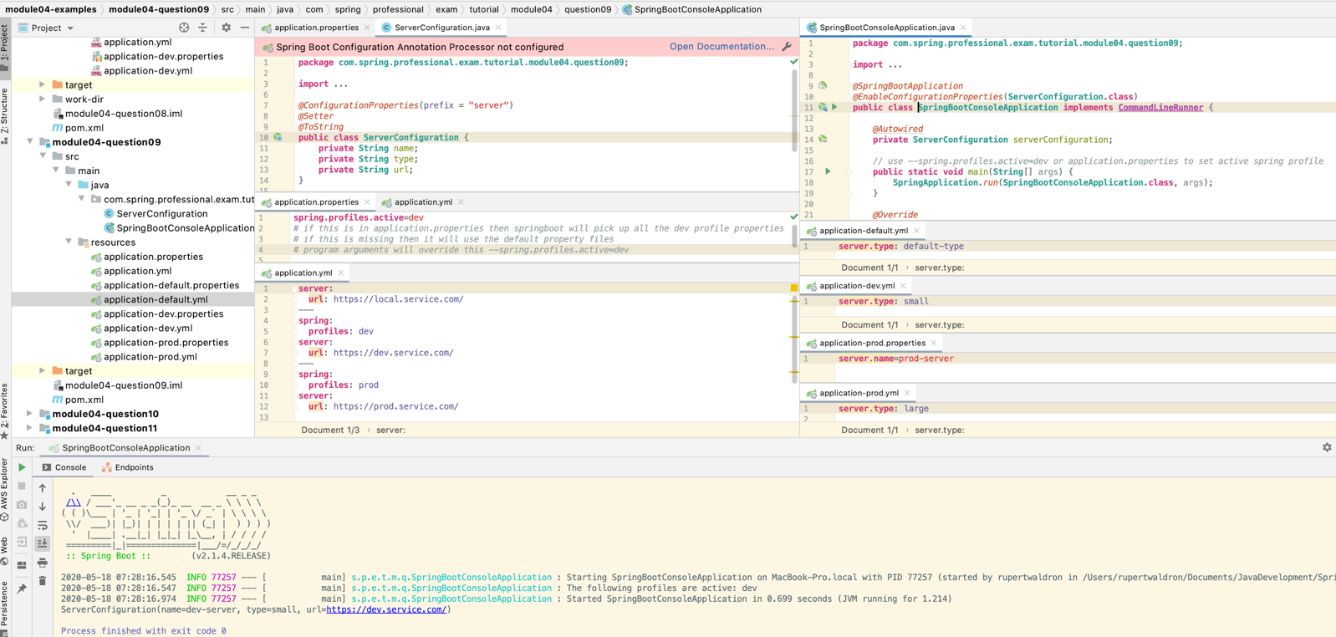

# Question 10-How do you access the properties defined in the property files?

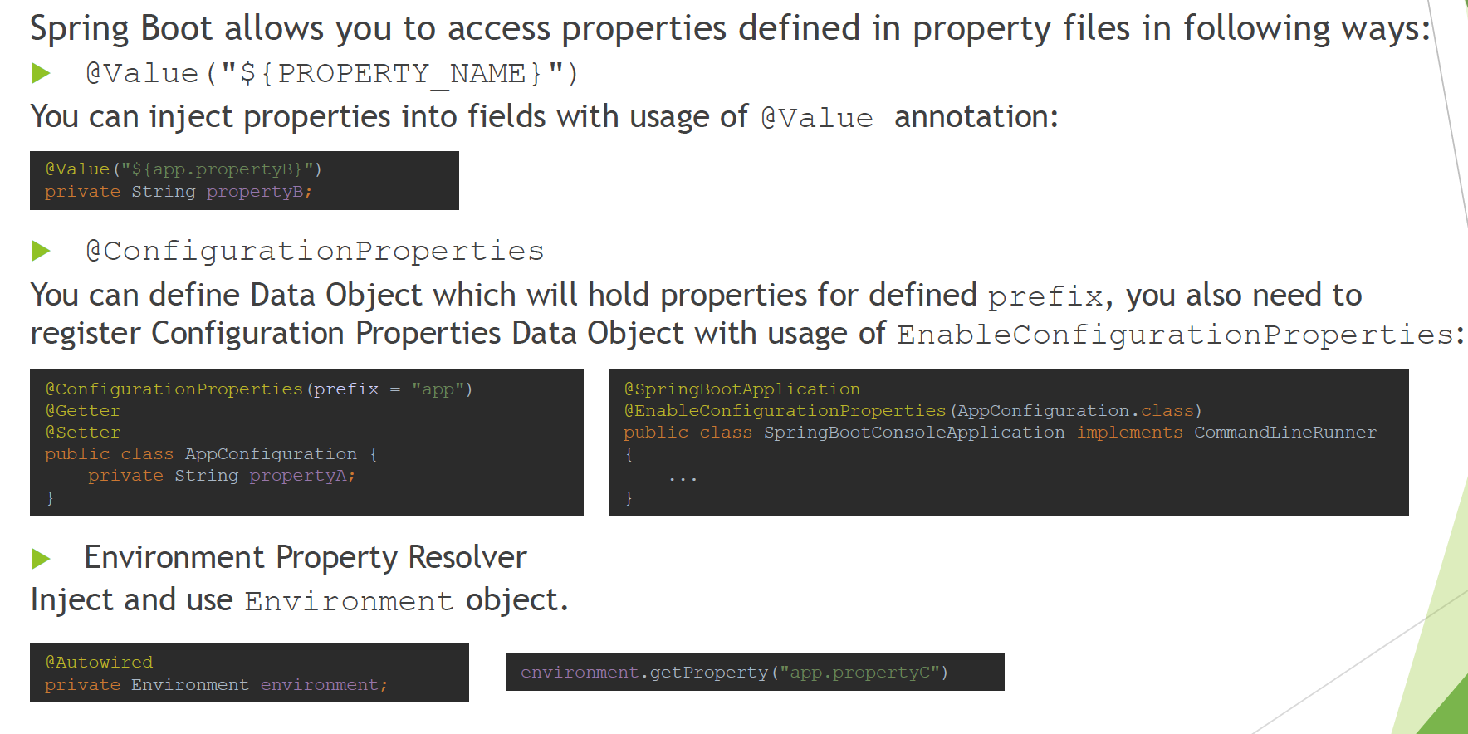

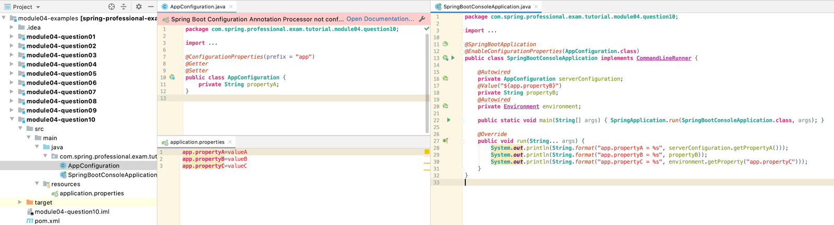

# Question 11-What properties do you have to define in order to configure external MySQL?

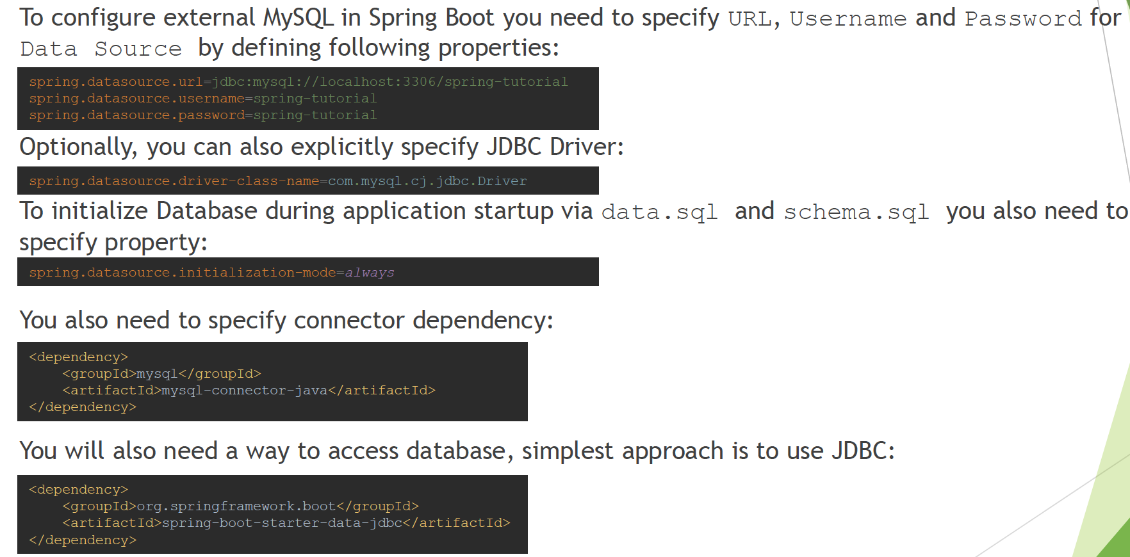

# Question 12-How do you configure default schema and initial data?

Spring Boot uses following scripts to configure default schema and initial data:

* schema.sql–contains DDL for db objects creation
* data.sql–contains data that should be inserted upon db initialization

Spring Boot will also load:

* schema-${platform}.sql
* data-${platform}.sql

platform is the value of spring.datasource.platform property, this allows you to switch between database vendor specific scripts, for example platform may be mysql, postgressql, oracleetc.

Spring Boot will automatically initialize **only embedded** databases, if you want to initialize regular database as well, you need to set property spring.datasource.initialization-mode to always.

If you would like to change default schema.sql and data.sql script names, you can use spring.datasource.schema and spring.datasource.data properties to achieve this.

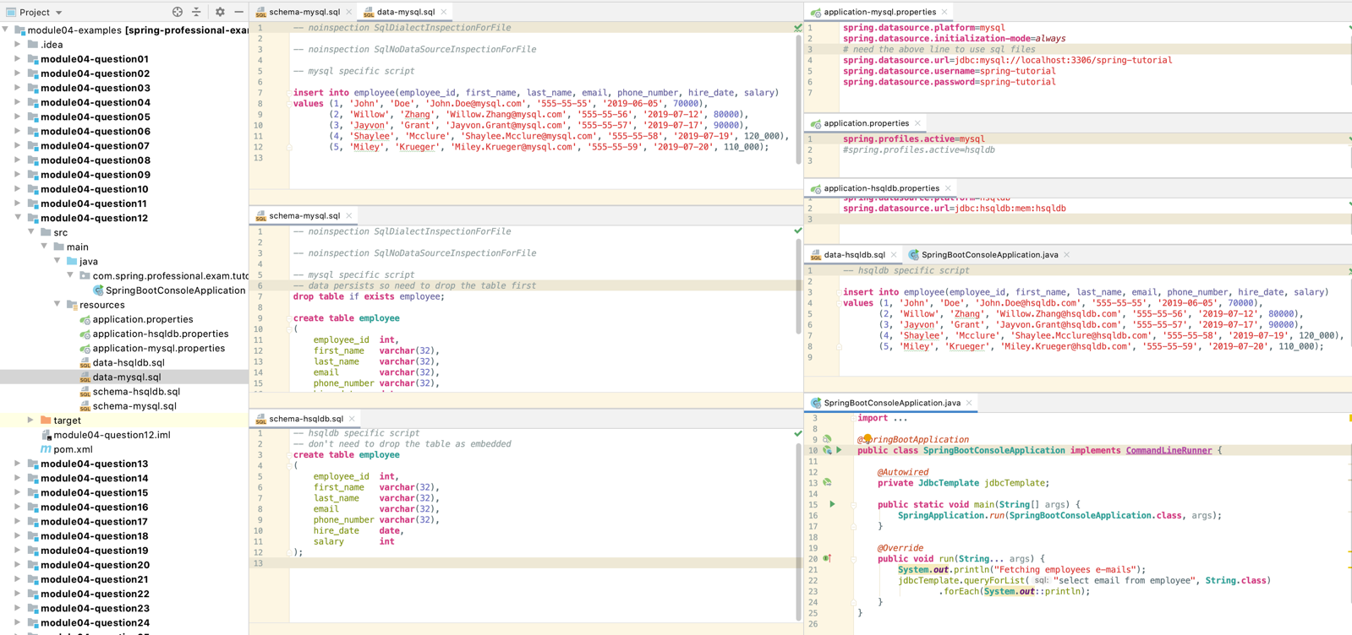

# Question 13-What is a fat jar? How is it different from the original jar?

Fat jar, also called “executable jar”, is a jar that contains compiled code for your application and also all dependencies. Spring Boot uses nested jars approach, that means that fat jar contains all dependencies as nested jars. This differs from other approach, which is uber jar that packs all dependencies into single jar archive. Uber jar approach is problematic because it is hard to see application dependencies and also causes issues when same filename in the same context is used in different jars.

Fat jar is often called “executable jar” because Spring Boot will generate MANIFEST.MF file which contains Main-Class and Start-Class entries together with JarLauncher code. This manifest together with launcher code will be used to execute standalone jar.

To create fat jar in your project, you need to use spring-boot-maven-plugin.

Executing application is as simple as executing one command:

java -jar spring-boot-application-1.0-SNAPSHOT.jar

The differences in comparison to original jar are following:

* Original jar does not contain all dependencies
* Original jar is not executable by default

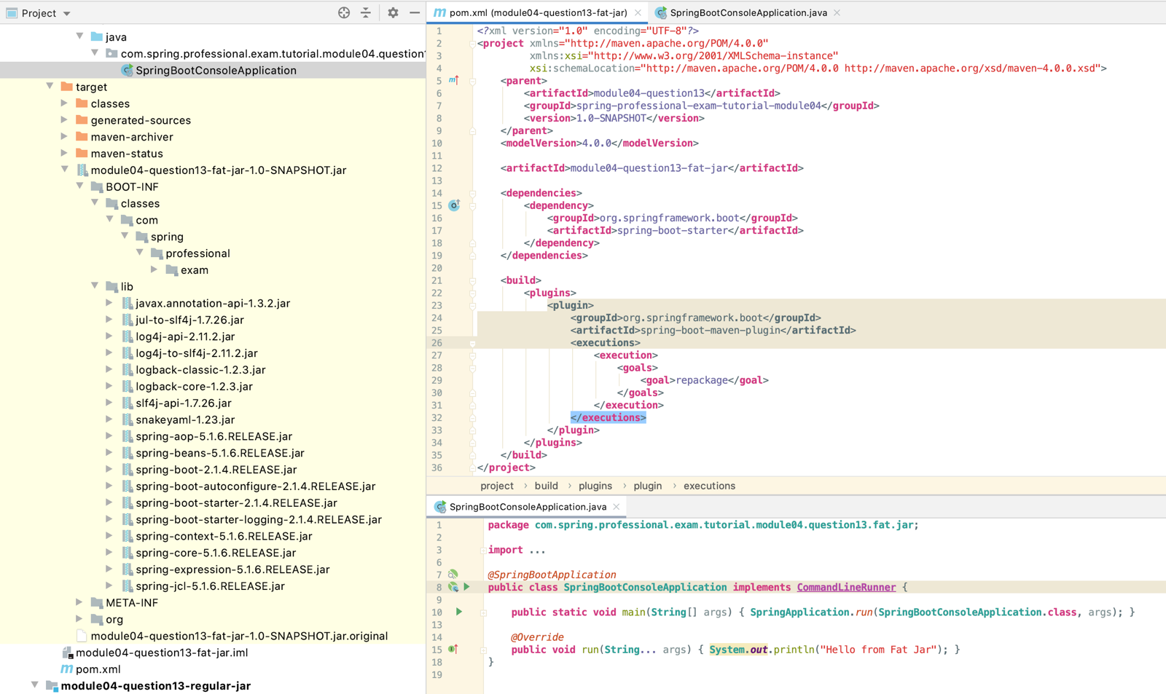

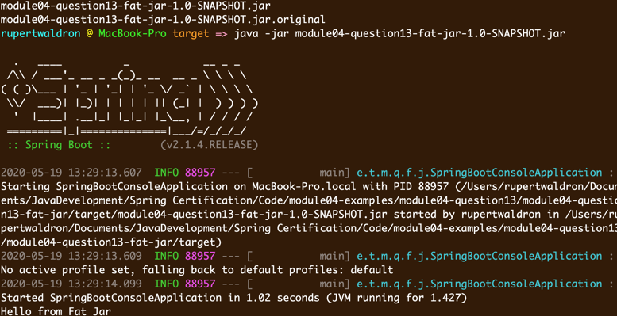

# Question 14-What is the difference between an embedded container and a WAR?

WAR (Web Application Archive) is a file that represents web module. WAR cannot be executed in standalone mode, it needs to be deployed to Application Server like Tomcat or WildFly.

Embedded container is used to execute executables jars. Embedded container is packed as dependency in executable jar and will be responsible for executing only single application. WAR approach on the other hand uses Application Server which might be used to execute multiple applications at the same time.

WAR file has following structure:

* Assembly root:
* JSP Pages, static HTML pages
* META-INF/
* MANIFEST.MF
* WEB-INF/
* web.xml (not required for Servlet 3+)
* lib/
* classes/
* tags/

Spring Boot Executable JAR has following structure:

* Assembly root:
* BOOT-INF/
* classes/
* lib/
* . . .
* tomcat-embed-core-9.0.17.jar
* . . .
* META-INF/
* MANIFEST.MF
* org.springframework.boot.loader
* . . .
* JarLauncher.class
* . . .

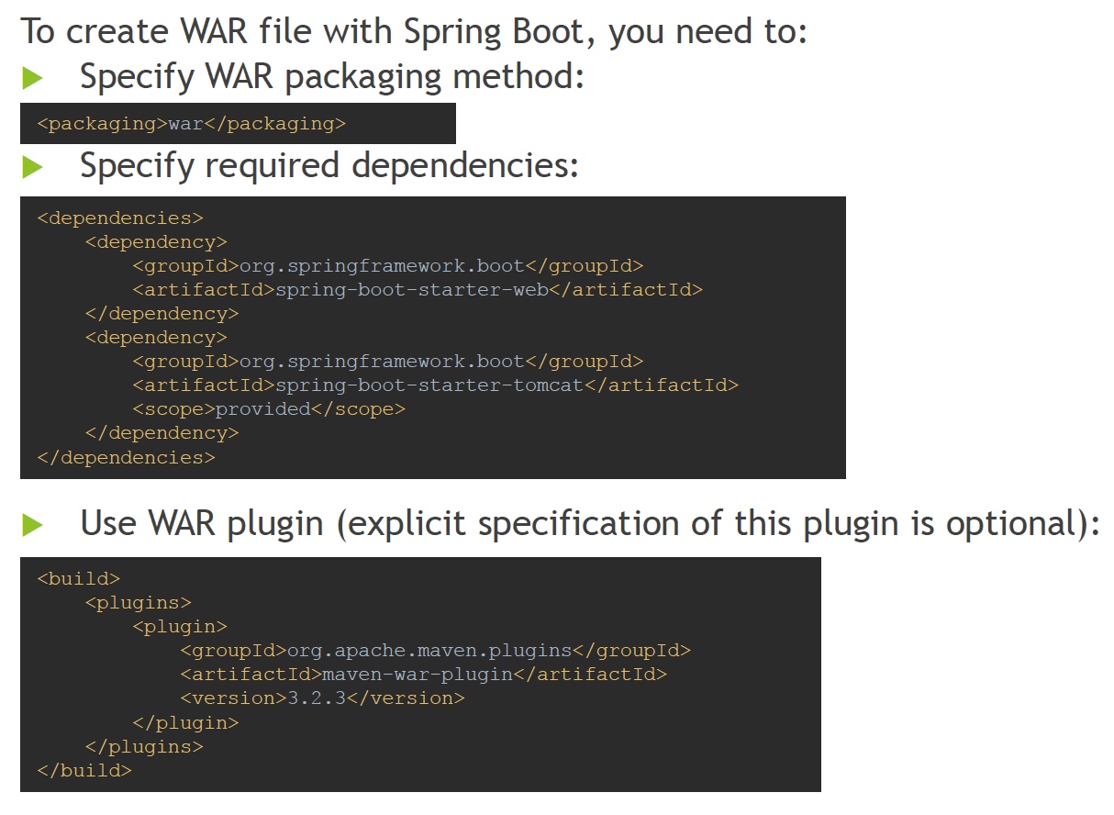

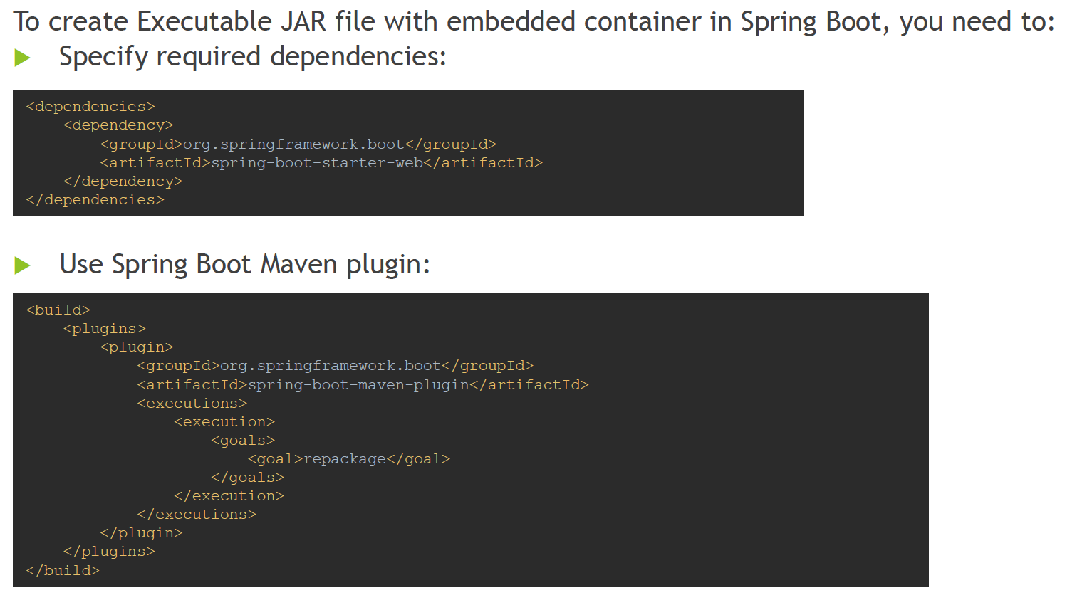

# Question 15 -What embedded containers does Spring Boot support?

Spring Boot supports following embedded containers:

* Tomcat
* Jetty
* Undertow

Tomcat is used as default embedded container, it will be automatically included when application is using spring-boot-starter-web:

## Tomcat

*<?*xml version="1.0" encoding="UTF-8"*?>*<**project** xmlns="http://maven.apache.org/POM/4.0.0"  
 xmlns:xsi="http://www.w3.org/2001/XMLSchema-instance"  
 xsi:schemaLocation="http://maven.apache.org/POM/4.0.0 http://maven.apache.org/xsd/maven-4.0.0.xsd">  
 <**parent**>  
 <**artifactId**>module04-question15</**artifactId**>  
 <**groupId**>spring-professional-exam-tutorial-module04</**groupId**>  
 <**version**>1.0-SNAPSHOT</**version**>  
 </**parent**>  
 <**modelVersion**>4.0.0</**modelVersion**>  
  
 <**artifactId**>module04-question15-tomcat</**artifactId**>  
  
 <**dependencies**>  
 <**dependency**>  
 <**groupId**>org.springframework.boot</**groupId**>  
 <**artifactId**>spring-boot-starter-web</**artifactId**>  
 </**dependency**>  
 </**dependencies**>  
  
 <**build**>  
 <**plugins**>  
 <**plugin**>  
 <**groupId**>org.springframework.boot</**groupId**>  
 <**artifactId**>spring-boot-maven-plugin</**artifactId**>  
 <**executions**>  
 <**execution**>  
 <**goals**>  
 <**goal**>repackage</**goal**>  
 </**goals**>  
 </**execution**>  
 </**executions**>  
 </**plugin**>  
 </**plugins**>  
 </**build**>  
</**project**>

## Jetty

<**dependencies**>  
 <**dependency**>  
 <**groupId**>org.springframework.boot</**groupId**>  
 <**artifactId**>spring-boot-starter-web</**artifactId**>  
 <**exclusions**>  
 <**exclusion**>  
 <**groupId**>org.springframework.boot</**groupId**>  
 <**artifactId**>spring-boot-starter-tomcat</**artifactId**>  
 </**exclusion**>  
 </**exclusions**>  
 </**dependency**>  
 <**dependency**>  
 <**groupId**>org.springframework.boot</**groupId**>  
 <**artifactId**>spring-boot-starter-jetty</**artifactId**>  
 </**dependency**>  
</**dependencies**>

## Undertow

<**dependencies**>  
 <**dependency**>  
 <**groupId**>org.springframework.boot</**groupId**>  
 <**artifactId**>spring-boot-starter-web</**artifactId**>  
 <**exclusions**>  
 <**exclusion**>  
 <**groupId**>org.springframework.boot</**groupId**>  
 <**artifactId**>spring-boot-starter-tomcat</**artifactId**>  
 </**exclusion**>  
 </**exclusions**>  
 </**dependency**>  
 <**dependency**>  
 <**groupId**>org.springframework.boot</**groupId**>  
 <**artifactId**>spring-boot-starter-undertow</**artifactId**>  
 </**dependency**>  
</**dependencies**>

# Section 3 – Spring Boot Auto Configuration

# Question 16 -How does Spring Boot know what to configure?

Spring Boot knows what to configure by usage of Auto Configuration Classes defined in starter modules. SpringBoot searches for META-INF/spring.factories on classpath, whenever entry org.springframework.boot.autoconfigure.EnableAutoConfigurationis encountered in this file, Auto Configuration Class pointed by this property is loaded.

Auto Configuration class is a regular @Configuration class annotated with @ConditionalOn... annotation which specifies under which conditions @Configuration class should be loaded.

When conditions from @ConditionalOn... annotation are matched, @Configuration class is loaded which provides beans that integrates your application with specified technology.

Auto Configuration is often used with starter modules. Starter module provides set of dependencies, and optionally may provide Auto Configuration classes.

Spring Boot supports following Conditional Annotations for AutoConfigurationclasses:

* ConditionalOnBean–presence of Spring Bean
* ConditionalOnMissingBean–absence of Spring Bean
* ConditionalOnClass–presence of class on classpath
* ConditionalOnMissingClass–absence of class on classpath
* ConditionalOnCloudPlatform–if specified cloud platform is active –for example Cloud Foundry
* ConditionalOnExpression–if SpEL expression is true
* ConditionalOnJava–presence of Java in specified version
* ConditionalOnJndi–if JNDI location exists
* ConditionalOnWebApplication–if a web application that uses WebApplicationContextor StandardServletEnvironment
* ConditionalOnNotWebApplication–application that is not a web application
* ConditionalOnProperty–presence of spring property
* ConditionalOnResource–presence of resource
* ConditionalOnSingleCandidate–only one candidate for the bean found

## Just using Spring Boot with embedded -be-autoconfig in other module

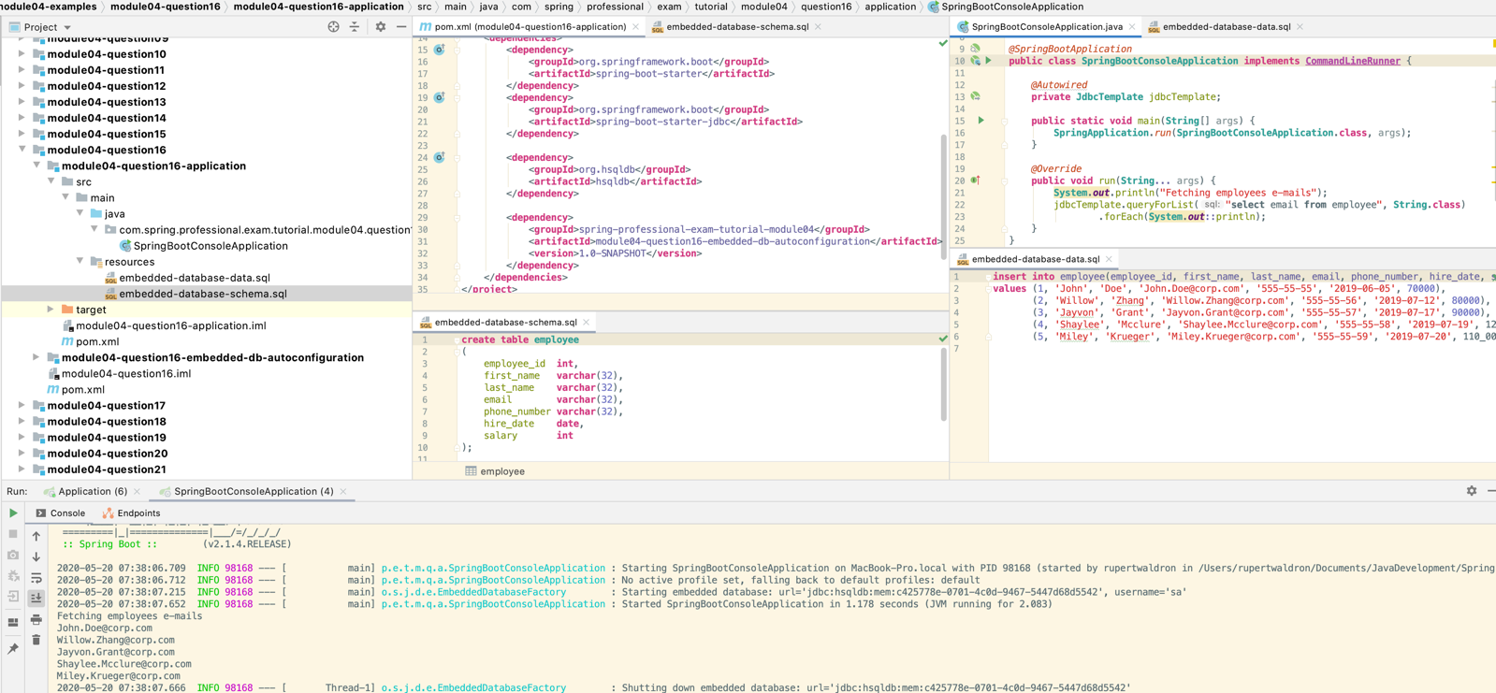

## Auto-configuration dependency on embedded database

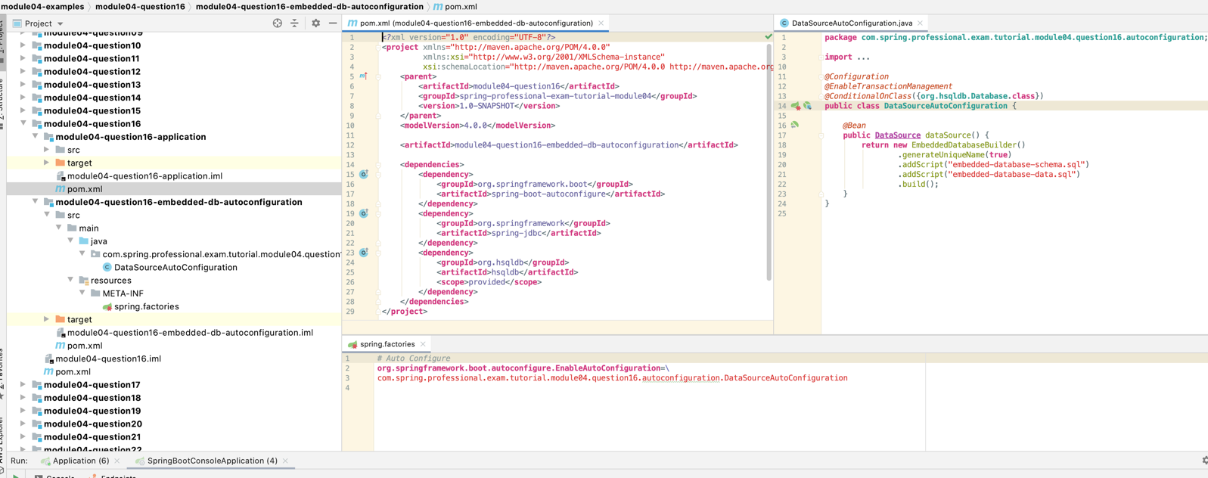

# Question 17-What does @EnableAutoConfigurationdo?

@EnableAutoConfigurationannotationturns on auto-configuration of Spring Context. Auto-configuration tries to guess Spring Beans that should be created for your application based on configured dependencies and configurations with @ConditionalOn... annotations.

When auto-configuration is turned on, Spring will search for META-INF/spring.factories on classpath, whenever entry org.springframework.boot.autoconfigure.EnableAutoConfiguration is encountered in this file, Auto Configuration Class pointed by this property is loaded. When condition present in @ConditionalOn... annotation is matched, beans pointed out by this configuration are created.

@EnableAutoConfigurationannotation should be applied to your application @Configuration class, when using Spring Boot with @SpringBootApplicationannotation, @EnableAutoConfigurationannotation is not required because auto-configuration is turned on by default.

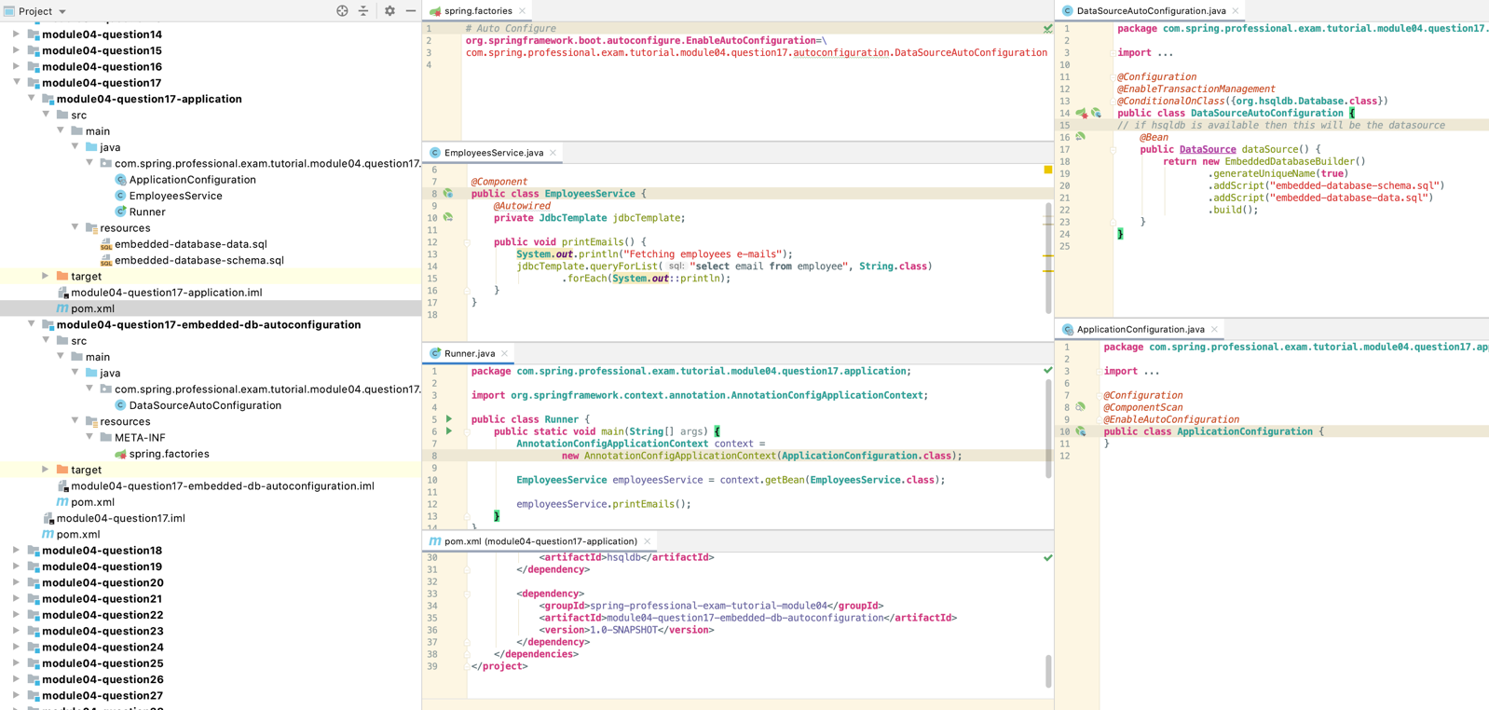

# Question 18-What does @SpringBootApplicationdo?

@SpringBootApplicationannotation is supposed to be used on top of the class and it was introduced for convenience. Usage of @SpringBootApplicationannotation is equivalent to usage of following three annotations:

* @Configuration –allows additional bean registration
* @EnableAutoConfiguration–enables context auto-configuration
* @ComponentScan –turns on scanning for @Component annotated classes

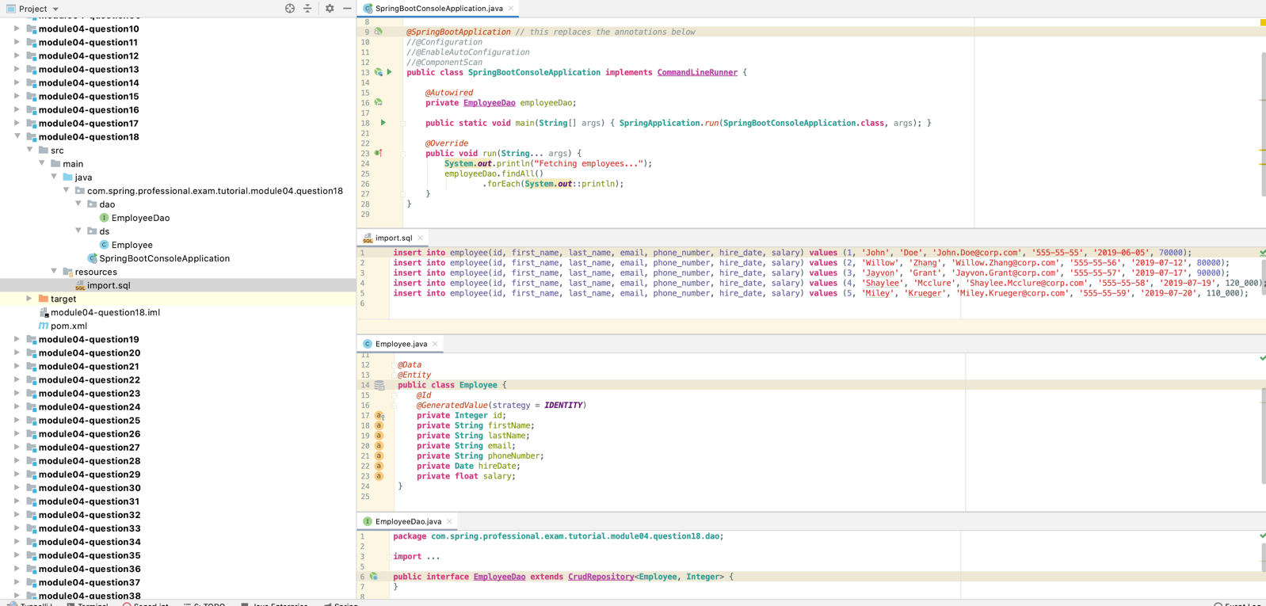

# Question 19-Does Spring Boot do component scanning? Where does it look by default?

Yes, Spring Boot is performing component scan, because @SpringBootApplicationannotation is enabling component scanning with usage of @ComponentScan annotation.

By default, Spring Boot will search for @Component annotated classes within the same root package as @SpringBootApplicationannotated class.

You can change this behaviour by adding additional packages to scan with scanBasePackages or type-safe version of it scanBasePackageClasses within @SpringBootApplicationannotation.

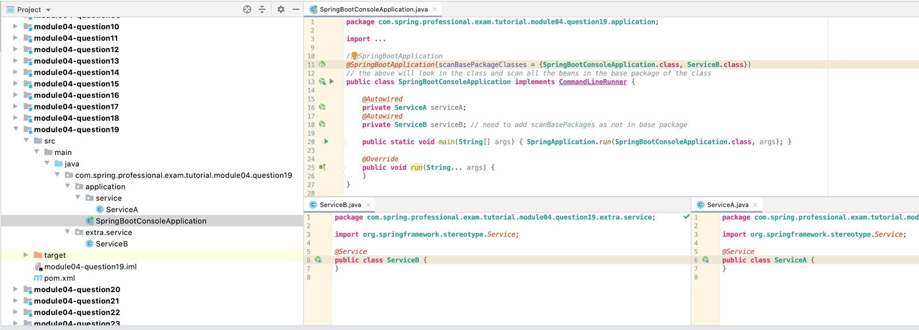

# Question 20-How are DataSourceand JdbcTemplate auto-configured?

DataSource and JdbcTemplateare configured by Auto Configuration Classes defined in spring-boot-autoconfigure module.

DataSource is configured by DataSourceAutoConfiguration, JdbcTemplate is configured by JdbcTemplateAutoConfiguration. DataSourceAutoConfiguration requires some properties to be defined, example below shows MySQL configuration:

**spring.datasource.initialization-mode**=*always***spring.datasource.url**=jdbc:mysql://localhost:3306/spring-tutorial  
**spring.datasource.username**=spring-tutorial  
**spring.datasource.password**=spring-tutorial

Above properties will be injected into DataSourceProperties by the prefix spring.datasource and used by DataSourceAutoConfiguration.

After having Auto Configuration enabled by default in Spring Boot, configured properties and Database Connector on your classpath, you can just use @Autowireto inject DataSource or JdbcTemplate.

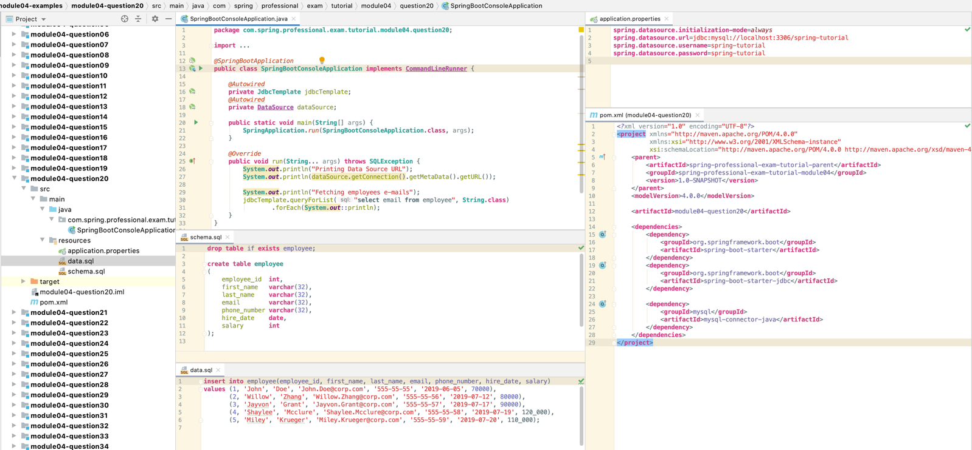

# Question 21-What is spring.factories file for?

spring.factories file, located in META-INF/spring.factories location on the classpath, is used by Auto Configuration mechanism to locate Auto Configuration Classes. Each module that provides Auto Configuration Class needs to have META-INF/spring.factories file with org.springframework.boot.autoconfigure.EnableAutoConfigurationentry that will point Auto Configuration Classes.

META-INF/spring.factories file is consumed by SpringFactoriesLoader class, which is used by AutoConfigurationImportSelector enabled by @EnableAutoConfigurationannotation used by default in @SpringBootApplication annotation.

Each Auto Configuration Class lists conditions, in which it should be applied, usually based on existence of specific class on the classpath or bean in the context. When conditions are met, @Configuration class produced beans within application context to integrate your application with desired technology.

Auto Configuration use case for spring.factories file is probably most popular one, it also allows you to define other entries and achieve context customization with following classes:

* ApplicationContextInitializer
* ApplicationListener
* AutoConfigurationImportFilter
* AutoConfigurationImportListener
* BeanInfoFactory
* ContextCustomizer
* DefaultTestExecutionListenersPostProcessor
* EnableAutoConfiguration
* EnvironmentPostProcessor
* FailureAnalysisReporter
* FailureAnalyzer
* ManagementContextConfiguration
* PropertySourceLoader
* ProxyDetector
* RepositoryFactorySupport
* SpringApplicationRunListener
* SpringBootExceptionReporter
* TemplateAvailabilityProvider
* TestExecutionListener

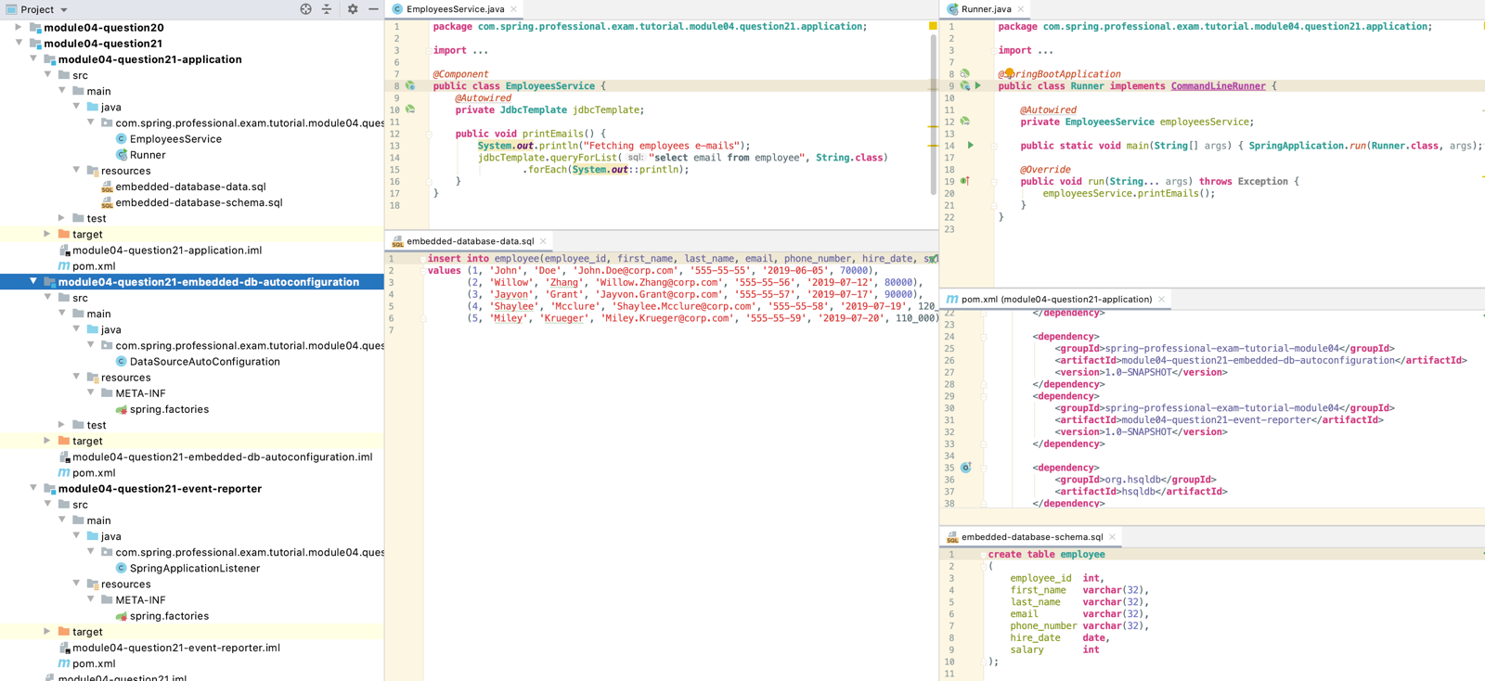

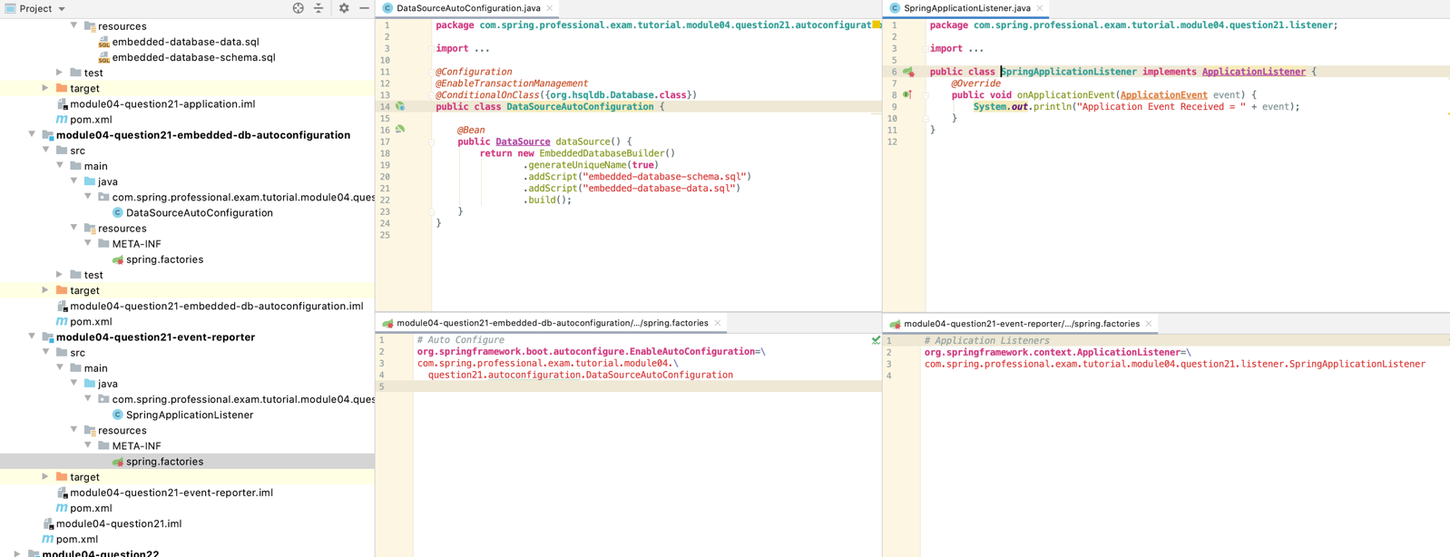

# Question 22-How do you customize Spring auto configuration?

You can customize Spring Auto Configuration by creating your own auto-configuration module with Auto Configuration Class.

To do that, you need to create java jar module which will contain META-INF/spring.factories file that contains org.springframework.boot.autoconfigure.EnableAutoConfiguration entry, which points to your Auto Configuration Class.

Auto Configuration Class is a class annotated with @Configuration annotation, usually used together with @ConditionalOnClass annotation. Additionally you can use @PropertySource annotation with @EnableConfigurationProperties and @ConfigurationProperties annotations to introduce custom properties for your auto-configuration module.

Inside Auto Configuration Class you should have @Bean annotated methods, which will provide configured beans when @ConditionalOnClassis met.

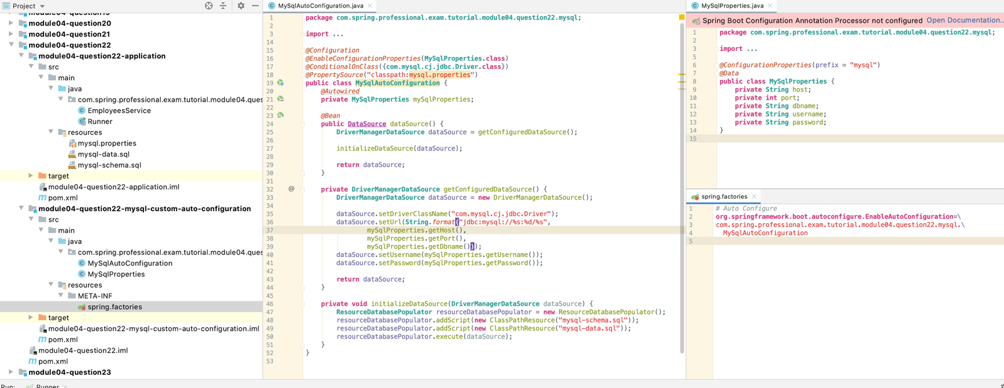

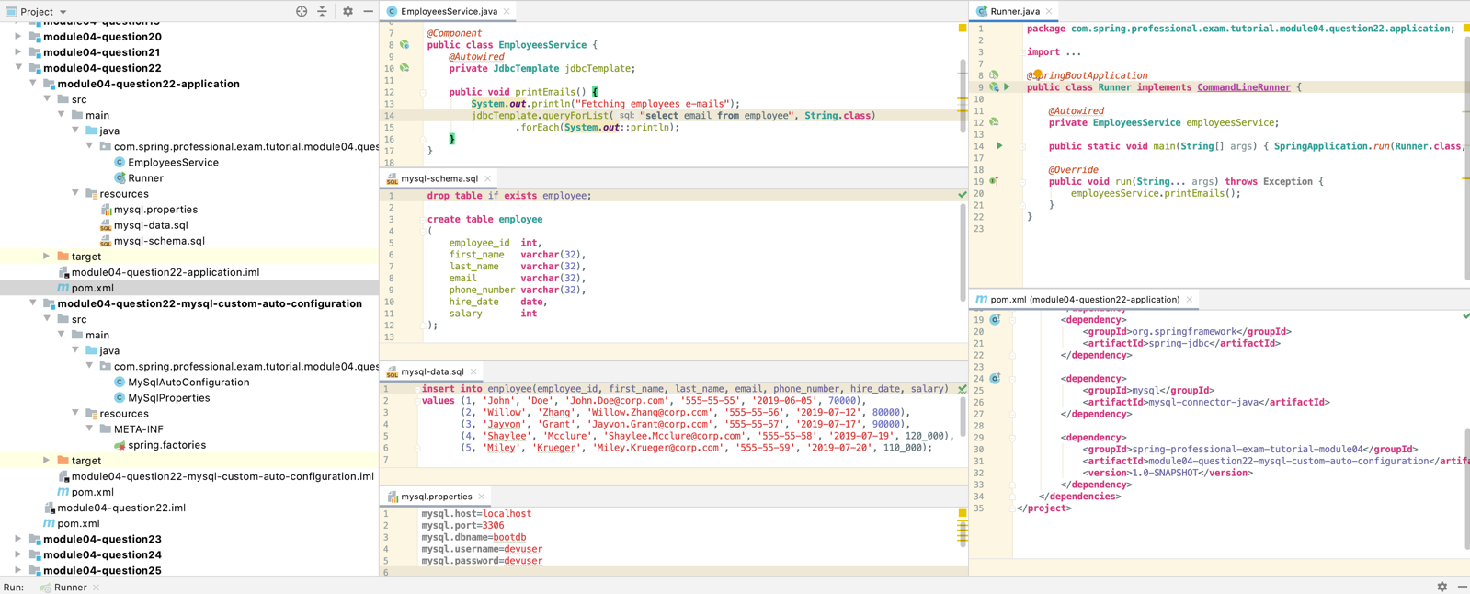

# Question 23-What are the examples of @Conditional annotations? How are they used?

Spring Boot supports following Conditional Annotations for Auto Configuration Classes:

* ConditionalOnBean–presence of Spring Bean
* ConditionalOnMissingBean–absence of Spring Bean
* ConditionalOnClass–presence of class on classpath
* ConditionalOnMissingClass–absence of class on classpath
* ConditionalOnCloudPlatform–if specified cloud platform is active –for example Cloud Foundry
* ConditionalOnExpression–if SpEL expression is true
* ConditionalOnJava–presence of Java in specified version
* ConditionalOnJndi–if JNDI location exists
* ConditionalOnWebApplication–if a web application that uses WebApplicationContextor StandardServletEnvironment
* ConditionalOnNotWebApplication–application that is not a web application
* ConditionalOnProperty–presence of spring property
* ConditionalOnResource–presence of resource
* ConditionalOnSingleCandidate–only one candidate for the bean found

@Conditional annotations are used together with Auto Configuration Classes, to indicate under which conditions, specific @Configuration class should apply.

*@Configuration  
@ConditionalOnProperty*(name = "file.store", havingValue = "network")  
**public class NetworkFileStoreAutoConfiguration** {  
 *@Bean* **public FileStore** networkFileStore() {  
 **return new** NetworkFileStore();  
 }  
}

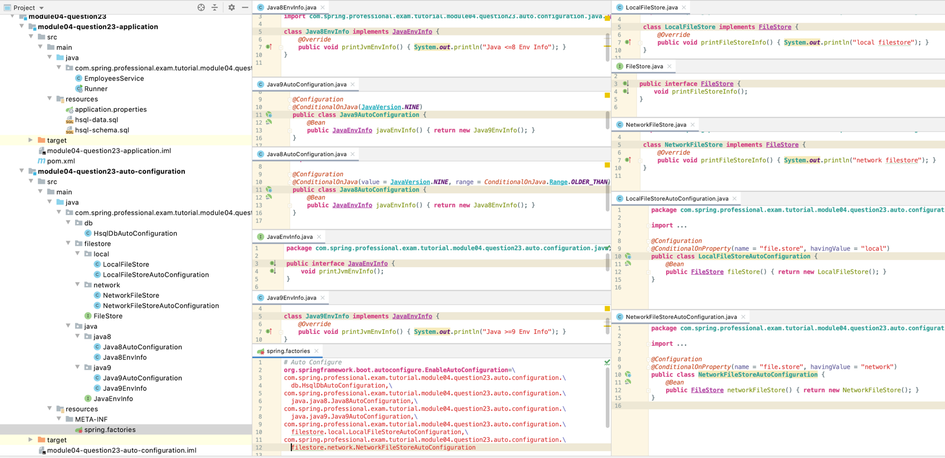

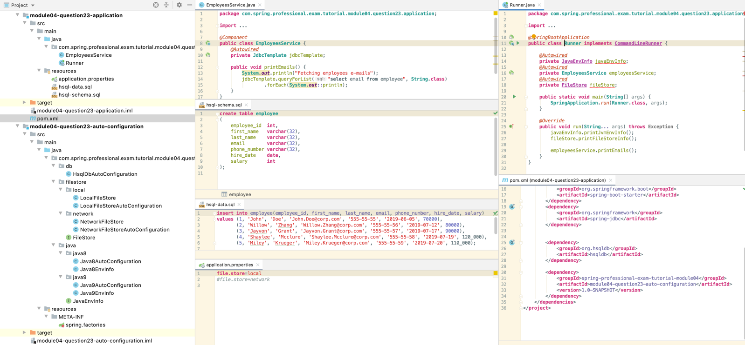

Java >=9 Env Info

local filestore

Fetching employees e-mails

John.Doe@corp.com

Willow.Zhang@corp.com

Jayvon.Grant@corp.com

Shaylee.Mcclure@corp.com

Miley.Krueger@corp.com

Question 24-What value does Spring Boot Actuator provide?

Spring Boot Actuator provides features, that are required for your application to be viewed as production ready product, such as:

* Monitoring
* Health-checks
* Metrics
* Audit Events

Advantage of using Spring Boot Actuator is that you can use those features in your product, without having to code them on your own, and enabling it, is as simple as putting dependency in your project:

<**dependency**>  
 <**groupId**>org.springframework.boot</**groupId**>  
 <**artifactId**>spring-boot-starter-actuator</**artifactId**>  
</**dependency**>

After that you can access endpoints available by default:

* /actuator/health
* /actuator/info

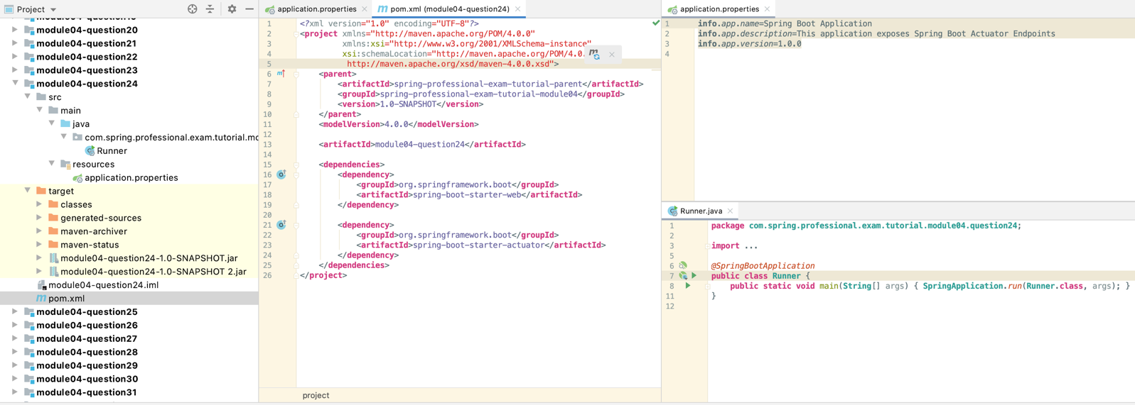

# Question 25-What are the two protocols you can use to access actuator endpoints?

Spring Boot Actuator supports two protocols:

* HTTP
* JMX

HTTP endpoints can be accessed by any HTTP Client, like CURL or Web Browser, by default following are enabled:

* /actuator/info
* /actuator/health

JMX allows you to access Actuator MBeans under org.springframework.bootgroup. You can access it with any tool that supports JMX protocol. One of the tool that you can use is JConsole which comes with JDK. You can access JMX:

* Locally by PID (enabled by default since Java SE 6)
* Remotely via Socket after enabling it with following Java VM flags (below example setup is simple but unsecure, do not use in production):
  + -Dcom.sun.management.jmxremote.local.only=false
  + -Dcom.sun.management.jmxremote.port=9010
  + -Dcom.sun.management.jmxremote.authenticate=false
  + -Dcom.sun.management.jmxremote.ssl=false

1. Run jconsole
2. 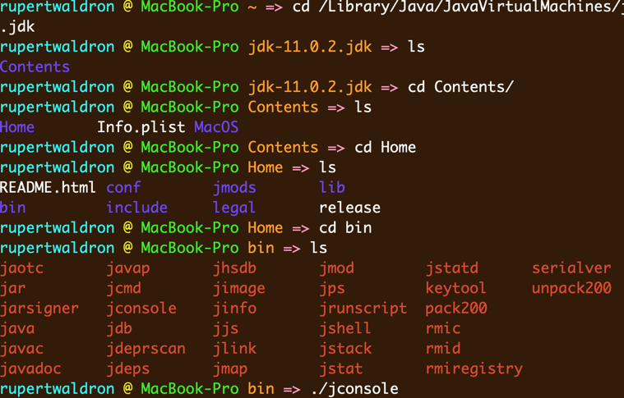
3. Find process
   1. 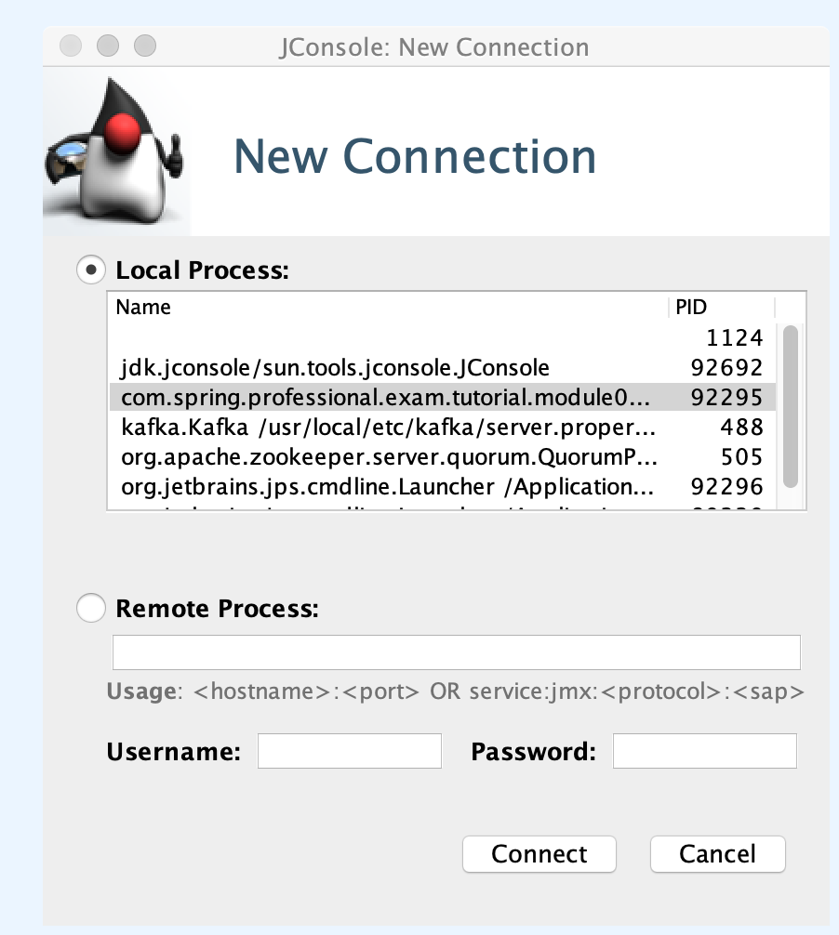
   2. 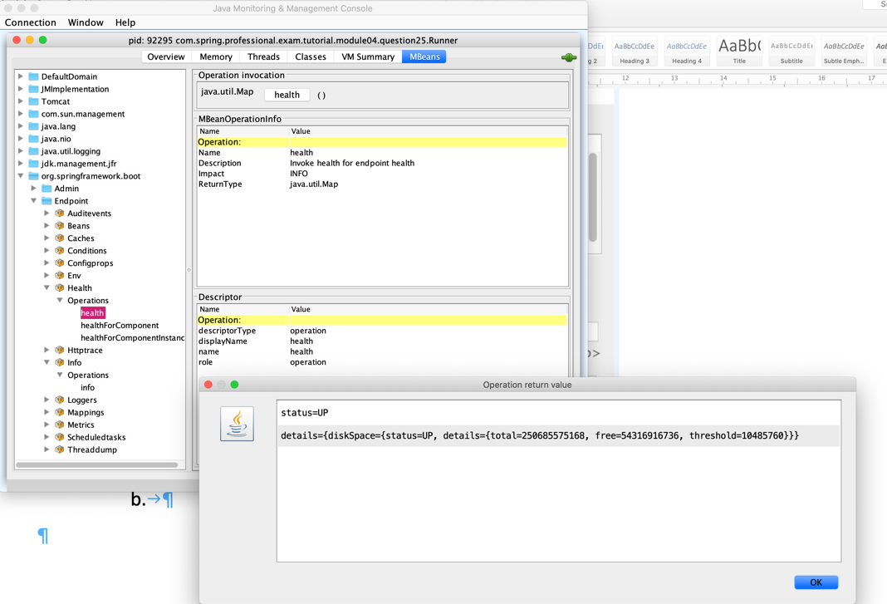
4. Can connect locally or remotely with the socket params above.

# Question 26-What are the actuator endpoints that are provided out of the box?

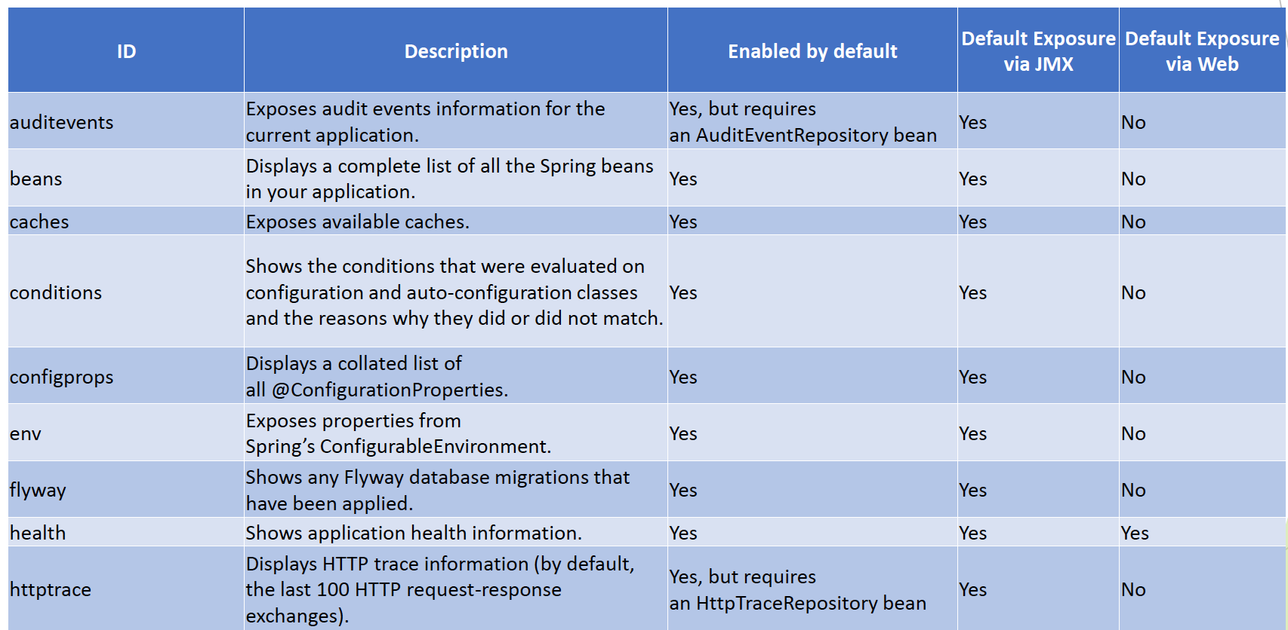

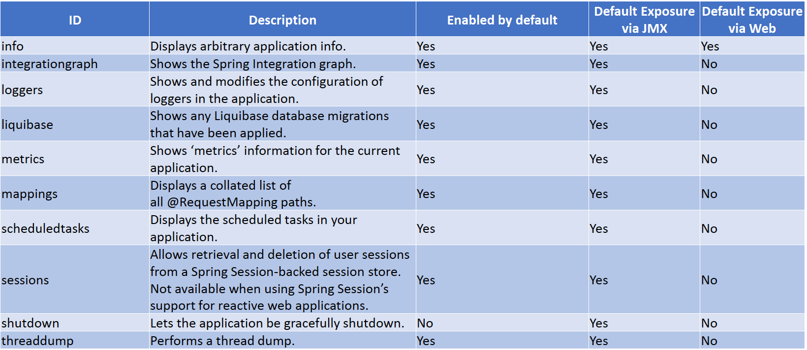

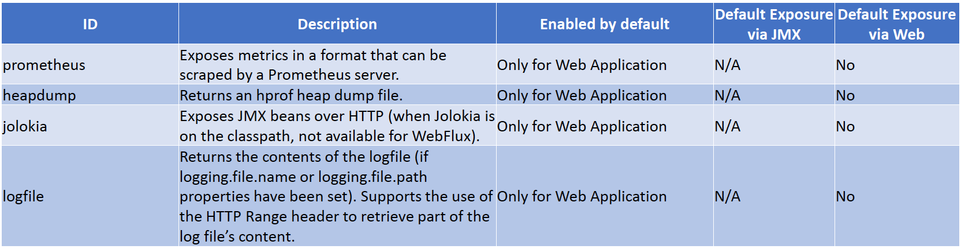

You can enable or disable Actuator Endpoints with usage of property:

management.endpoint.*${ENDPOINT_NAME}*.enabled=true

For example:

* management.endpoint.shutdown.enabled=true
* management.endpoint.beans.enabled=false
* management.endpoint.info.enabled=false

You can also disable ‘Enabled by default’ behaviour with usage of property:

* management.endpoints.enabled-by-default=false

You can change endpoints exposure with usage of properties:

* management.endpoints.jmx.exposure.exclude
* management.endpoints.jmx.exposure.include
* management.endpoints.web.exposure.exclude
* management.endpoints.web.exposure.include

For example:management.endpoints.web.exposure.include=info, health, env, beans

You can also expose all endpoints with usage of wildcard, for example:

* management.endpoints.web.exposure.include=*

You can enable navigation through Actuator Endpoints, by usage of HATEOAS.

To enable this navigation, all you have to do is to add dependency to your project:

<**dependency**>  
 <**groupId**>org.springframework.boot</**groupId**>  
 <**artifactId**>spring-boot-starter-hateoas</**artifactId**>  
</**dependency**>

After having this dependency, visiting main Actuator page:

<http://localhost:8080/actuator>

Will give you _links element in response, that can be used for navigation.

# Question 27-What is info endpoint for? How do you supply data?

Spring Boot Actuator info endpoint is used to provide arbitrary, non-sensitive, custom defined data, available at runtime that can provide additional information about started application.

info endpoint is exposed by default via protocols:

* HTTPat /actuator/info
* JMXat org.springframework.boot/Endpoint/Info

info endpoint is usually used to expose information like:

* Application Name, Description, Version
* Java Runtime Used
* Git Information –see git-commit-id-plugin
* Branch
* Tag
* Commit ID
* ...

You can supply data to Spring Boot by using following methods:

* With usage of property files, by defining info.* properties

**#application.properties file**

**info.app.name**=Spring Boot Application  
**info.app.description**=This application exposes Spring Boot Actuator Endpoints  
**info.app.version**=1.0.0  
**info.java-vendor**=${**java.specification.vendor**}

*@Component***public class SystemNameInfoContributor implements InfoContributor** {  
 *@Override* **public void** contribute(**Info**.**Builder** builder) {  
 builder.withDetail("system-name", **System**.*getProperty*("os.name"));  
 }  
}

# Question 28-How do you change logging level of a package using loggers endpoint?

Spring Actuator allows you to list currently configured loggers with their levels in following ways:

* via HTTPby visiting /actuator/loggers endpoint
* via JMXby executing org.springframework.boot/Endpoint/Loggers/Operations/loggers

loggers endpoint is exposed by default via JMX, to use it via HTTP you need to expose it by setting following property in application.properties:

* **management.endpoints.web.exposure.include**=loggers

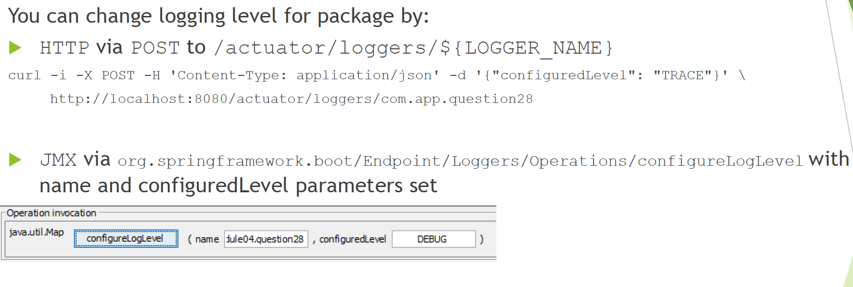

*@RestController***public class HelloController** {  
 **private Logger** logger = **LoggerFactory**.*getLogger*(**HelloController**.**class**);  
  
 *@GetMapping* **public String** index() {  
 logger.trace("TRACE Message");  
 logger.debug("DEBUG Message");  
 logger.info("INFO Message");  
 logger.warn("WARN Message");  
 logger.error("ERROR Message");  
  
 **return** "OK";  
 }  
}

# Question 29-How do you access an endpoint using a tag?

You access an endpoint using a tag by defining it as part of the request in following way: tag=KEY:VALUE.

For example:

/actuator/metrics/http.server.requests?tag=status:200

/actuator/metrics/jvm.memory.max?tag=area:heap

You can also use multiple tags in one query with usage of &in following way:

tag=KEY1:VALUE1&tag=KEY2:VALUE2

For example:

/actuator/metrics/http.server.requests?tag=status:200&tag=method:GET

/actuator/metrics/jvm.memory.max?tag=area:heap&tag=id:G1%20Old%20Gen

Tag is used to filter results of query by one or multiple dimensions. It is often used with metricsendpoint for data filtering.

# Question 30-What is metrics for?

Spring Actuator provides metrics endpoint which can be used to examine metrics collected by the application during runtime.

metrics endpoint allows you to view information about specific metric by visiting metric dedicated URI, for example /actuator/metrics/process.cpu.usage

metricsendpoint allows you to drill down information further by usage of available tags, for example/actuator/metrics/jvm.memory.used?tag=area:heap

metricsendpoint allows you to view many out-of-the box defined metrics:

* CPUUsage, CPU Core Count
* Memory Usage, Max Memory Available
* ThreadsInfo
* Garbage CollectorStatistics
* HTTP Requests Info
* Embedded Tomcat Related Metrics
* ... (many more, also you can define custom metrics)

metrics endpoint is not exposed via Web by default, to have it available, you need to add following entry to application.properties:

* management.endpoints.web.exposure.include=metrics

# Question 31-How do you create a custom metric with or without tags?

Spring Boot Actuator allows you to create custom metrics with usage of MeterRegistry from Micrometer Application Metrics Facade.

Micrometer used by Spring Boot Actuator allows you to register following Meter Primitives that will be exposed via /actuator/metrics endpoint:

* Counter
* Gauge
* Timer
* TimeGauge
* DistributionSummary
* LongTaskTimer
* FunctionCounter
* FunctionTimer

You can get more information on Meter Primitives from Micrometer Documentation:

* <https://micrometer.io/docs>

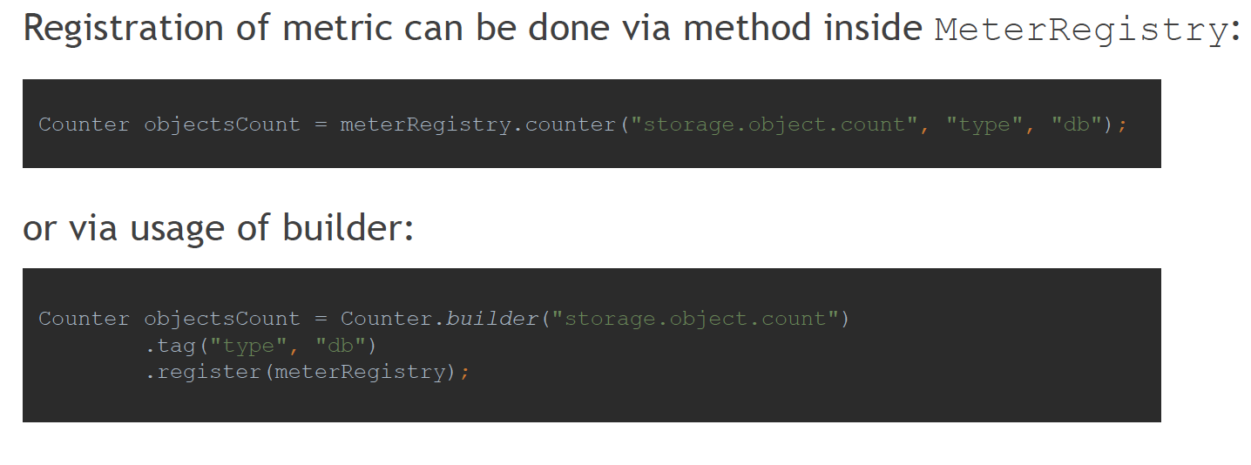

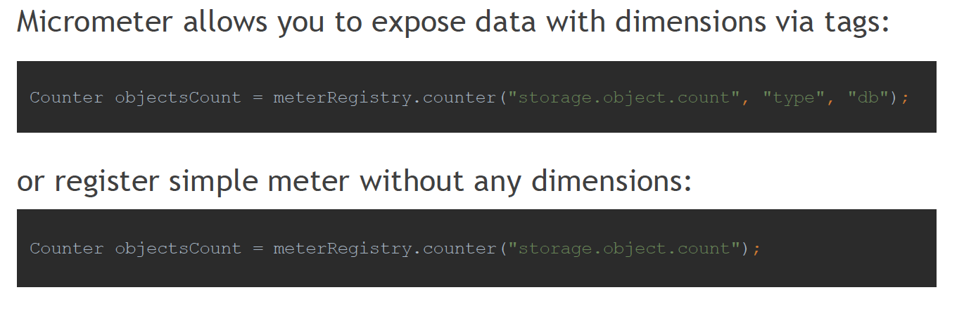

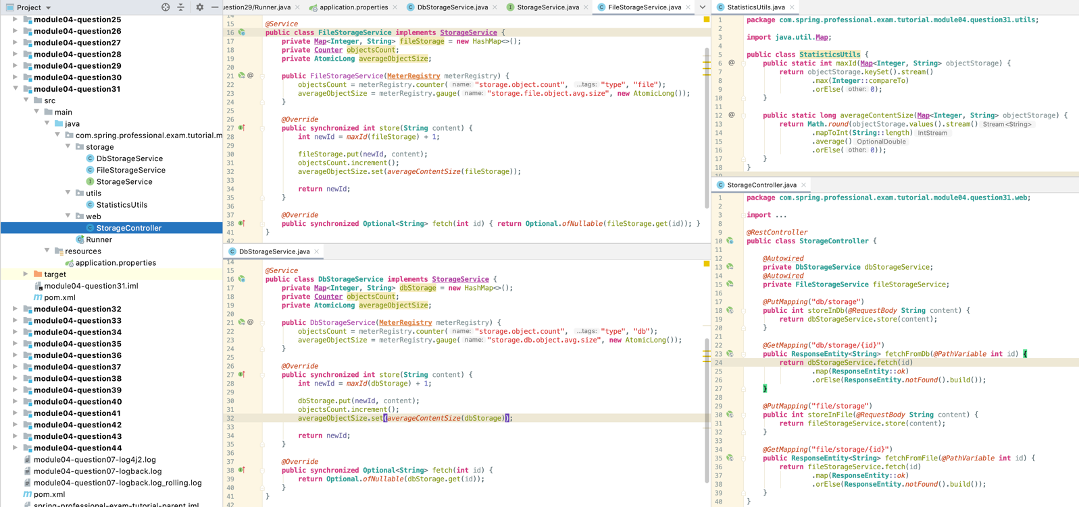

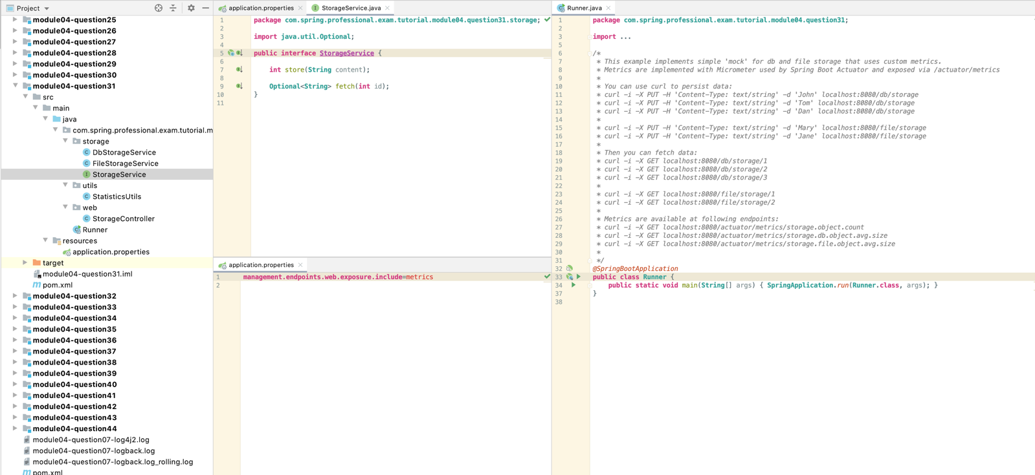

# Question 32-What is Health Indicator?

Health Indicator is a component used by /actuator/health endpoint to check if system is in a state which can be used to successfully handle requests.

/actuator/health endpoint is returning aggregated information on system status by evaluating all Health Indicators registered in HealthIndicatorRegistry.

/actuator/health endpoint is exposed by default via both JMX and Web, however default configuration is exposing only minimal set of information.

This endpoint is used, usually by monitoring software, to periodically check system status, upon receiving failed status, automated alert is sent to product support team.

Monitoring endpoint like this, is also very useful when building Highly Available and Fault Tolerant Architecture, in this case such endpoint can be used by Load Balancer to check which instances are healthy and can accept traffic.

To changel evel of details exposed by/actuator/health endpoint, following properties can be used:

* management.endpoint.health.show-details
* management.endpoint.health.show-components

Both of them can support following values:

* never–detailed information are never shown (default value)
* when-authorized–show information to users with roles from property management.endpoint.health.roles
* always–detailed information are shown to all users

To create custom Health Indicator, Spring Bean has to be created that implements Health Indicator interface:

*@Component***public class CustomHealthIndicator implements HealthIndicator** {  
 *@Override* **public Health** health() {  
 **return Health**.*up*()  
 .withDetail("system-ready", **true**)  
 .build();  
 }  
}

application.properties file

**management.endpoint.health.show-details**=*always***management.endpoint.health.show-components**=always

# Question 33-What are the Health Indicators that are provided out of the box?

Spring Actuator provides following Health Indicators that are configured when proper dependencies are found:

* ApplicationHealthIndicator-Default Implementation, always up.
* DiskSpaceHealthIndicator-Checks for low disk space.
* DataSourceHealthIndicator-Checks the status of a DataSource and optionally runs a test query.
* CassandraHealthIndicator-Checks that a Cassandra database is up.
* CouchbaseHealthIndicator-Checks that a Couchbase cluster is up.
* ElasticsearchHealthIndicator-Checks that an Elasticsearch cluster is up.
* HazelcastHealthIndicator-Checks that a Hazelcastserver is up.
* InfluxDbHealthIndicator-Checks that an InfluxDBserver is up.
* JmsHealthIndicator-Checks that a JMS broker is up.
* MailHealthIndicator-Checks that a mail server is up.
* MongoHealthIndicator-Checks that a Mongo database is up.
* RabbitHealthIndicator-Checks that a Rabbit server is up.
* RedisHealthIndicator-Checks that a Redis server is up.
* SolrHealthIndicator-Checks that a Solr server is up.

Neo4jHealthIndicator-Checks the status of a Neo4j by executing a Cypher.

Spring Actuator also provides Reactive Health Indicators for reactive applications, like those using Spring WebFlux:

* CassandraReactiveHealthIndicator-Checks that a Cassandra database is up.
* CouchbaseReactiveHealthIndicator-Checks that a Couchbase cluster is up.
* MongoReactiveHealthIndicator-Checks that a Mongo database is up.
* RedisReactiveHealthIndicator-Checks that a Redis server is up.

**management.endpoint.health.show-details**=*always***management.endpoint.health.show-components**=always

# Question 34-What is the Health Indicator status?

Health Indicator status is used by Health Indicators to inform Spring Actuator if system component checked by them is working correctly or not.

Each Health Indicator is expected to return status that represents guarded component state, statuscanbe one of following:

* UP
* DOWN
* OUT_OF_SERVICE
* UNKNOWN
* Custom Defined

Spring Actuator is also using HealthAggregator, especially OrderedHealthAggregatort o aggregate statuses from all Health Indicators and decide on final status. OrderedHealthAggregatoris taking statuses from all Health Indicators, sorts them by predefined order (DOWN, OUT_OF_SERVICE, UP, UNKNOWN), and takes first element after sorting, which represents highest priority status and becomes final status of the system.

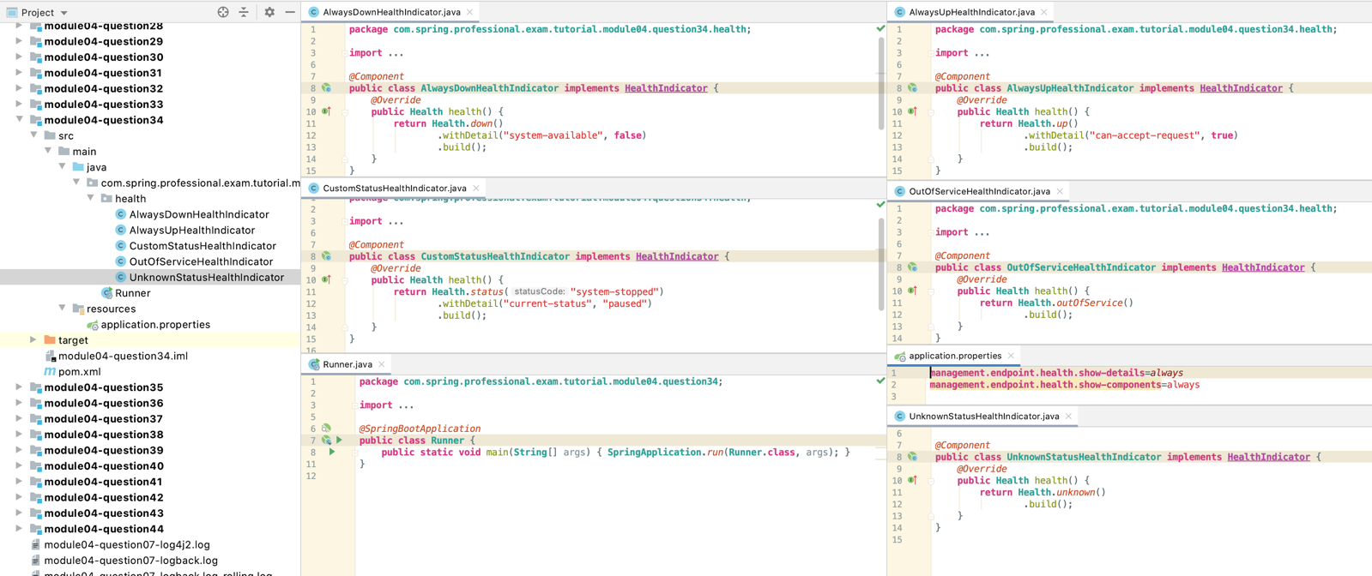

# Question 35-What are the Health Indicator statuses that are provided out of the box?

Spring Actuator provides following Health Indicator Statuses out of the box:

* UP-component or subsystem is functioning as expected
* DOWN-component or subsystem has suffered an unexpected failure
* OUT_OF_SERVICE-component or subsystem has been taken out of service and should not be used
* UNKNOWN-component or subsystem is in an unknown state

Based on Health Indicator Statuses from above, Spring will also perform default mapping of status to HTTP Response Code with usage of HealthStatusHttpMapper that follows this default configuration:

* UP-> HTTP 200
* UNKNOWN-> HTTP 200
* DOWN-> HTTP 503
* OUT_OF_SERVICE -> HTTP 503

You can change default mapping with usage of management.health.status.http-mappingproperty, for example:

management.health.status.http-mapping.DOWN=501

# Question 36-How do you change the Health Indicator status severity order?

Spring Actuator allows you to change Health Indicator Status severity order with usage of property management.health.status.order for example:

**management.endpoint.health.show-details**=*always***management.endpoint.health.show-components**=always  
**management.health.status.order**=system-halted, DOWN, OUT_OF_SERVICE, UNKNOWN, UP

This property will be injected into HealthIndicatorProperties and used by OrderedHealthAggregator to resolve final status for application by aggregating statuses from all Health Indicators available in the system.

# Question 37-Why do you want to leverage 3rd-party external monitoring system?

It is a good idea to use external monitoring system, because this way you can use monitoring functionalities without having to spend time coding them.

External monitoring system usually provides:

* Durable persistent storage
* Tested way of ingesting massive amount of data
* A way to query for data
* A way to perform data visualization
* Configurable Dashboards
* Configurable alerting

Spring Actuator uses Micrometer Application Metrics Facade which integrates with number of external monitoring systems. Provided dependency management and auto-configuration makes it easy to integrate Micrometer into your project.

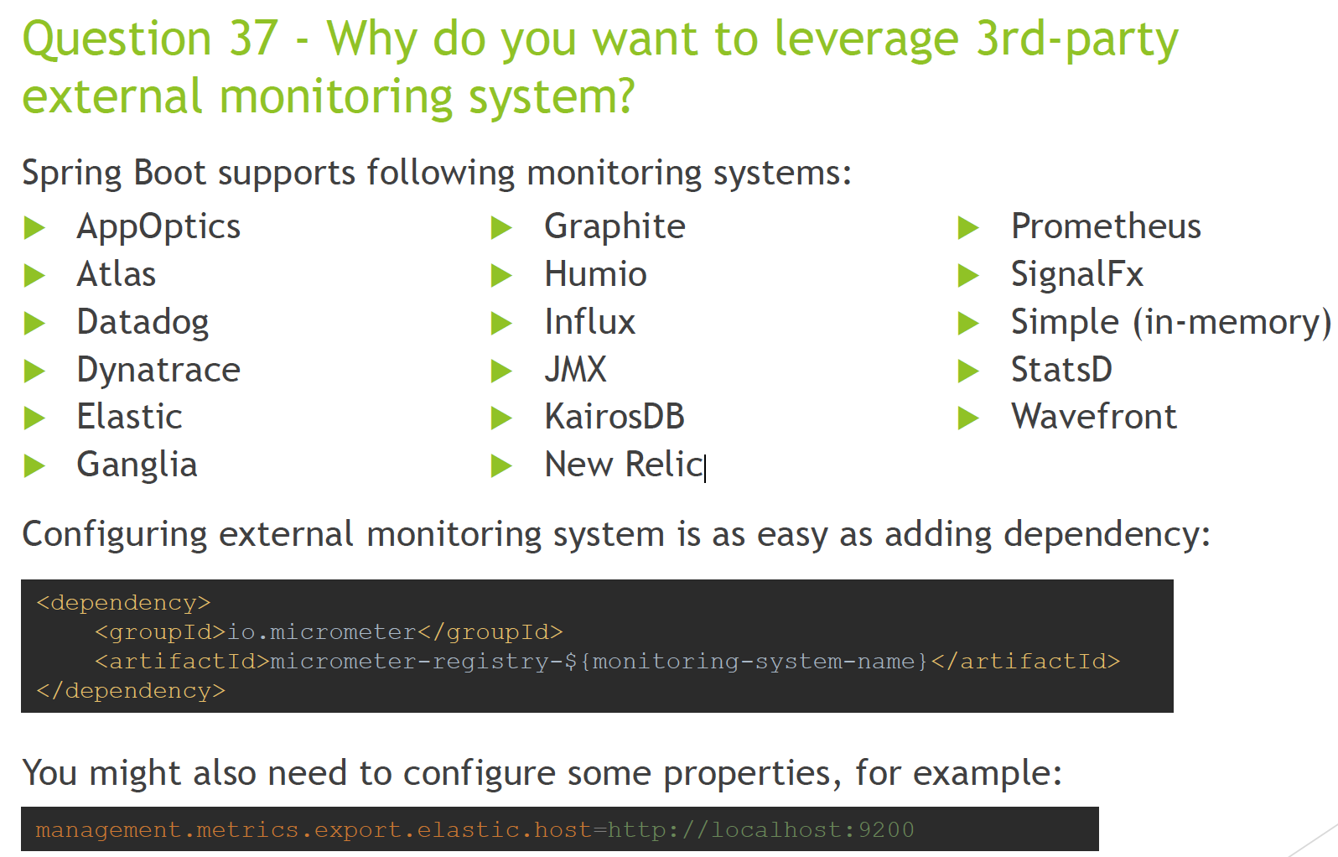

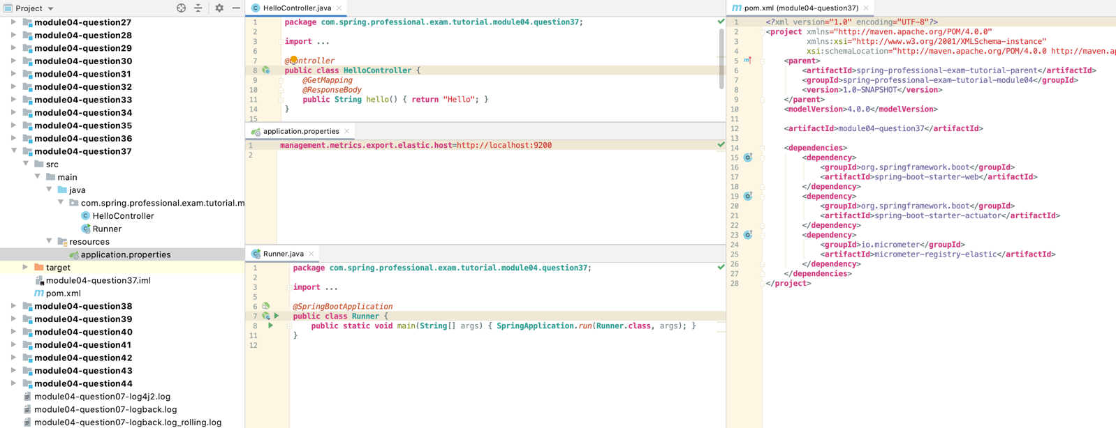

# Question 38-When do you want to use @SpringBootTest annotation?

You should use @SpringBootTest annotation whenever writing JUnit Integration Test for product that is using Spring Boot.

Spring Boot approach to Integration Testing simplifies it by eliminating requirement of application deployment or establishing connection to other infrastructure.

@SpringBootTest annotation enables Spring Boot specific features on top of Spring Test that are useful for testing, like:

* Automated Context creation through SpringApplication class
* Web Environment for Testing –Mocked or Embedded
* Mocked Bean Injection via @MockBean annotation
* Spy Injection via @SpyBean annotation
* Ability to customize created context with @TestConfiguration annotated classes
* Auto configurations for:
* MVC Testing
* JSON Testing
* JPA Tests
* JDBC Tests
* Mongo Db Tests
* and much more...

To use @SpringBootTest annotation, you will need to add @RunWith(SpringRunner.class) annotation on top of your test class first, this is required **only for JUnit 4**, for JUnit 5 @ExtendWith(SpringExtension.class) annotation is already contained in @SpringBootTest annotation.

Next you need to use @SpringBootTest annotation:

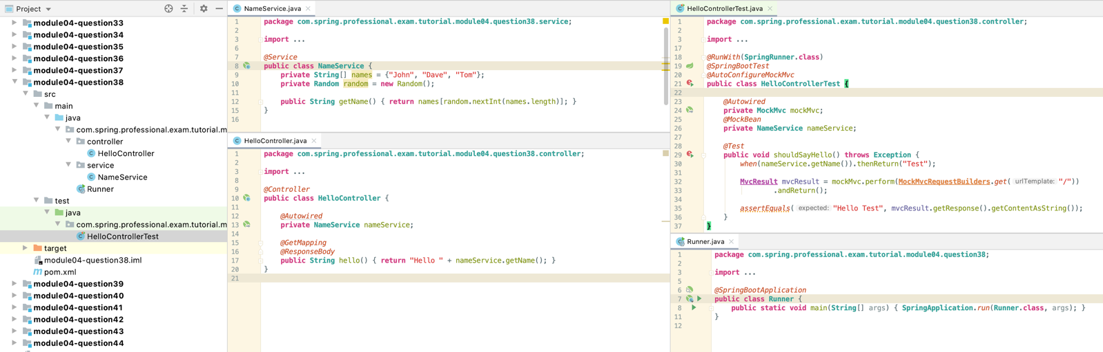

# Question 39-What does @SpringBootTest auto-configure?

@SpringBootTest annotation will auto-configure:

* ApplicationContext for testing
* Test itself with tools used for testing

ApplicationContext is configured by searching for @SpringBootApplicationor @SpringBootConfigurationannotated classes, based on those bean definitions will be created.

It is also possible to test only slice of the application with usage one of following:

* @SpringBootTest#classes
* @ContextConfiguration#classes
* @AutoConfigure…annotations

@AutoConfigure… annotations allows you to configure specific environment and tools for testing, for example @AutoConfigureMockMvc will configure Mock Mvc that can be used for Controllers testing.

Spring Boot Test includes annotations that are wrapping @AutoConfigure…annotationsand make test development simpler:

* @JsonTest
* @WebMvcTest
* @WebFluxTest
* @DataJpaTest
* @JdbcTest
* @JooqTest
* @DataMongoTest
* @DataLdapTest
* @RestClientTest
* ...

Each of this annotation uses @AutoConfigure…annotations and also @ExtendWith(SpringExtension.class) for JUnit 5, which makes test development easier.

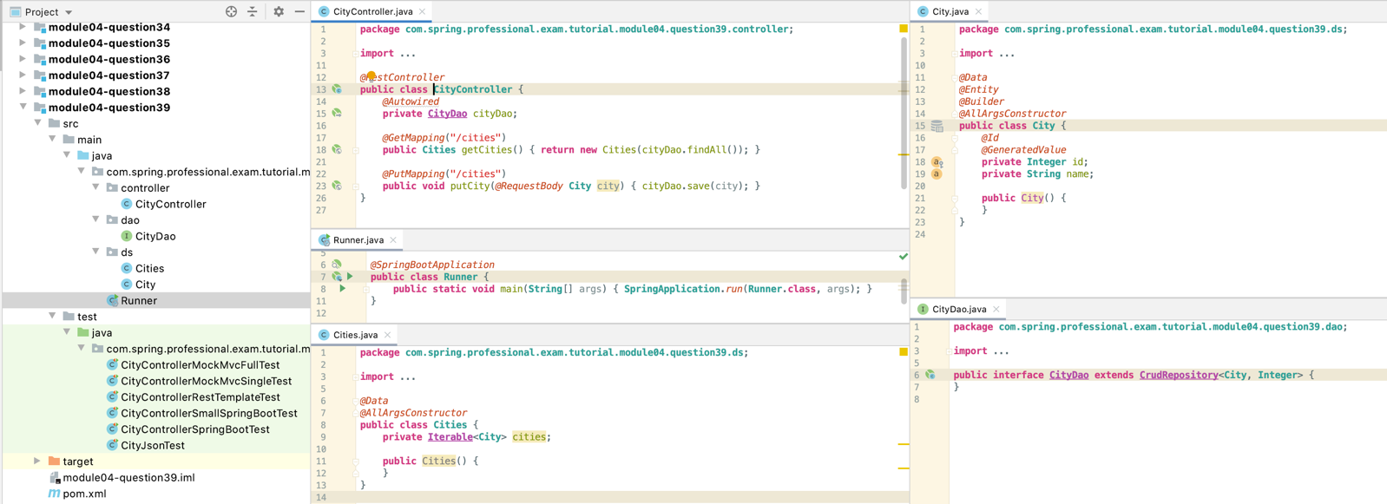

## 39.1 Full-Test – recommended use

*@RunWith*(**SpringRunner**.**class**)  
*@SpringBootTest  
@AutoConfigureMockMvc***public class CityControllerMockMvcFullTest** {  
  
 *@Autowired* **private MockMvc** mvc; *//all of the layers are created under the hood - integration test  
  
 @Test* **public void** shouldSaveCities() **throws Exception** {  
 mvc.perform(  
 *put*("/cities")  
 .content("{ \"name\": \"Los Angeles\" }")  
 .contentType(**MediaType**.***APPLICATION_JSON***)  
 ).andExpect(*status*().isOk());  
  
 mvc.perform(  
 *put*("/cities")  
 .content("{ \"name\": \"New York\" }")  
 .contentType(**MediaType**.***APPLICATION_JSON***)  
 ).andExpect(*status*().isOk());  
  
 **String** jsonResponse = mvc.perform(*get*("/cities"))  
 .andExpect(*status*().isOk())  
 .andReturn().getResponse().getContentAsString();  
  
 *assertThat*(jsonResponse)  
 .contains("{\"id\":1,\"name\":\"Los Angeles\"}")  
 .contains("{\"id\":2,\"name\":\"New York\"}");  
 }  
}

## 39.2 Single Test for Controller

*@RunWith*(**SpringRunner**.**class**)  
*@WebMvcTest*(**CityController**.**class**) *//single class instance so need to mock cityDao***public class CityControllerMockMvcSingleTest** {  
  
 *@Autowired* **private MockMvc** mvc;  
 *@MockBean* **private CityDao** cityDao;  
  
 *@Test* **public void** shouldSaveCity() **throws Exception** {  
 mvc.perform(  
 *put*("/cities")  
 .content("{ \"name\": \"Los Angeles\" }")  
 .contentType(**MediaType**.***APPLICATION_JSON***)  
 ).andExpect(*status*().isOk());  
  
 *verify*(cityDao).save(**new** City(**null**, "Los Angeles"));  
 }  
  
 *@Test* **public void** shouldFetchCities() **throws Exception** {  
 *when*(cityDao.findAll())  
 .thenReturn(**Arrays**.*asList*(  
 **new** City(1, "Los Angeles"),  
 **new** City(2, "New York")  
 ));  
  
 **String** jsonResponse = mvc.perform(*get*("/cities"))  
 .andExpect(*status*().isOk())  
 .andReturn()  
 .getResponse()  
 .getContentAsString();  
  
 *assertThat*(jsonResponse)  
 .contains("{\"id\":1,\"name\":\"Los Angeles\"}")  
 .contains("{\"id\":2,\"name\":\"New York\"}");  
 }  
}

## 39.3 RestTemplate – Recommended for full integration environment

*@RunWith*(**SpringRunner**.**class**)  
*@SpringBootTest*(webEnvironment = *SpringBootTest*.**WebEnvironment**.***RANDOM_PORT***)  
**public class CityControllerRestTemplateTest** {  
  
 *@LocalServerPort* **private int** port;  
  
 *@Autowired* **private TestRestTemplate** restTemplate;  
  
 *@Test* **public void** shouldSaveCities() {  
 **String** url = **String**.*format*("http://localhost:%d/cities", port);  
  
 restTemplate.put(url, **City**.*builder*().name("Los Angeles").build());  
 restTemplate.put(url, **City**.*builder*().name("New York").build());  
  
 **Cities** cities = restTemplate.getForEntity("/cities", **Cities**.**class**).getBody();  
  
 *assertThat*(cities.getCities())  
 .containsOnly(  
 **new** City(1, "Los Angeles"),  
 **new** City(2, "New York")  
 );  
 }  
}

## 39.4 Small Springboot Test

*@RunWith*(**SpringRunner**.**class**)  
*@SpringBootTest*(classes = **CityController**.**class**) // limits classes created in the application context  
**public class CityControllerSmallSpringBootTest** {  
  
 *@Autowired* **private CityController** cityController;  
 *@MockBean* **private CityDao** cityDao;  
  
 *@Test* **public void** shouldSaveFewCities() {  
 cityController.putCity(**City**.*builder*().name("Los Angeles").build());  
 cityController.putCity(**City**.*builder*().name("New York").build());  
 cityController.putCity(**City**.*builder*().name("San Francisco").build());  
  
 *verify*(cityDao).save(**new** City(**null**, "Los Angeles"));  
 *verify*(cityDao).save(**new** City(**null**, "New York"));  
 *verify*(cityDao).save(**new** City(**null**, "San Francisco"));  
 }  
  
 *@Test* **public void** shouldFetchCities() {  
 *when*(cityDao.findAll())  
 .thenReturn(**Arrays**.*asList*(  
 **new** City(1, "Los Angeles"),  
 **new** City(2, "New York")  
 ));  
  
 **Cities** fetchedCities = cityController.getCities();  
  
 *assertThat*(fetchedCities.getCities())  
 .containsOnly(  
 **new** City(1, "Los Angeles"),  
 **new** City(2, "New York")  
 );  
 }  
}

## 39.5 Controller Springboot test – no mocking

*@RunWith*(**SpringRunner**.**class**)  
*@SpringBootTest***public class CityControllerSpringBootTest** {  
  
 *@Autowired* **private CityController** cityController;  
  
 *@Test* **public void** shouldSaveFewCities() {  
 cityController.putCity(**City**.*builder*().name("Los Angeles").build());  
 cityController.putCity(**City**.*builder*().name("New York").build());  
 cityController.putCity(**City**.*builder*().name("San Francisco").build());  
  
 *assertThat*(cityController.getCities().getCities())  
 .containsOnly(  
 **new** City(1, "Los Angeles"),  
 **new** City(2, "New York"),  
 **new** City(3, "San Francisco")  
 );  
 }  
}

## 39.6 JsonTest

*@RunWith*(**SpringRunner**.**class**)  
*@JsonTest***public class CityJsonTest** {  
 *@Autowired* **private JacksonTester**<**City**> json;  
  
 *@Test* **public void** shouldSerialize() **throws IOException** {  
 **City** city = **new** City(1, "New York");  
  
 **String** json = **this**.json.write(city).getJson();  
  
 *assertEquals*(json, "{\"id\":1,\"name\":\"New York\"}");  
 }  
  
 *@Test* **public void** shouldDeserialize() **throws IOException** {  
 **City** city = json.parse("{\"id\":1,\"name\":\"New York\"}").getObject();  
  
 *assertEquals*(*valueOf*(1), city.getId());  
 *assertEquals*("New York", city.getName());  
 }  
}

# Question 40-What dependencies does spring-boot-starter-test brings to the classpath?

spring-boot-starter-test brings following dependencies:

* JUnit -Unit Testing for Java Applications
* Spring Test -Spring Framework Support for Testing
* Spring Boot Test -Utilities and Integration Test Support for Spring Boot
* AssertJ-Fluent Assertion Library
* Hamcrest-Matchers Library
* Mockito -Mocking Framework
* JSONassert-JSON Assertion Library
* JsonPath-XPath for JSON
* XMLUnit-Tools for XML verification

You can see list of all dependencies with versions for maven module by running following command:

mvn dependency:tree

# Question 41-How do you perform integration testing with @SpringBootTest for a web application?

Integration Test by definition, should check interactions between few components of the system (at least two real, not-mocked components) to check if those components are delivering expected functionalities when working together. In each case when writing Integration Test you should decide how many components should interact in the test for it to be meaningful. Usually you should decide on smallest possible amount of components that are enough to test specific functionality. Components that are not meaningful can be omitted, or mocked with usage of @MockBean annotation.

Web components tests (Controller Tests, Rest Controller Tests), if tested in Integration way, should be written in a way for test to make a HTTP Request and check HTTP Response. This kind of approach results in meaningful test, which delivers feedback that actually checks if component works correctly.

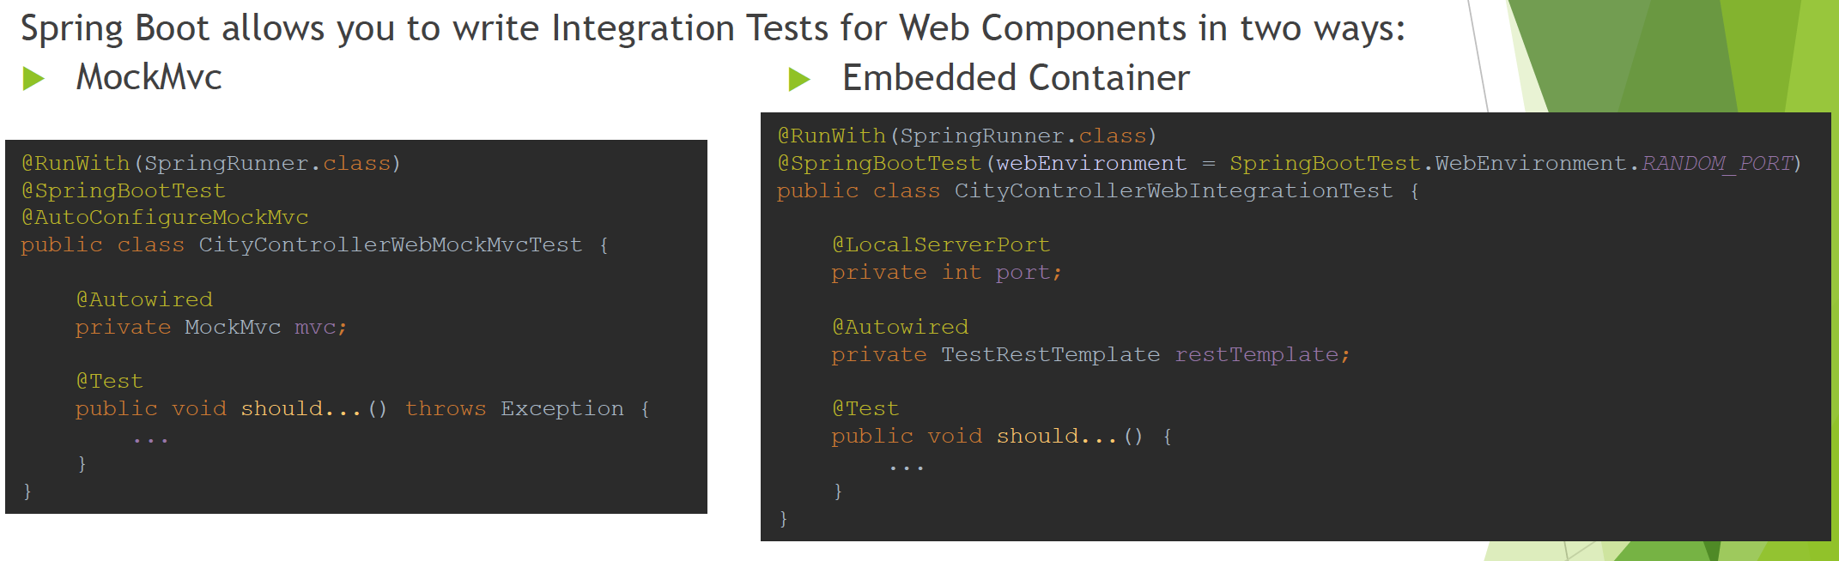

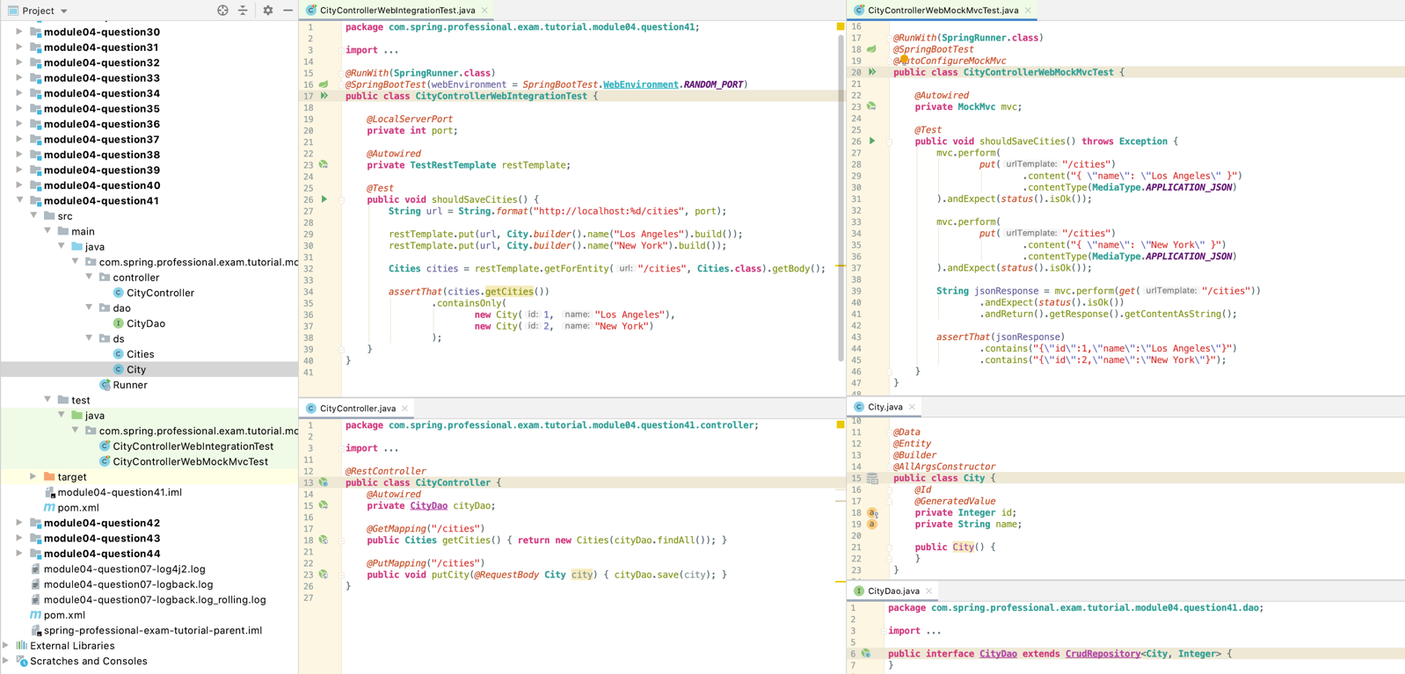

# Question 42-When do you want to use @WebMvcTest? What does it auto-configure?

You should use @WebMvcTestannotation when you want to write Integration Test that is focused on web layer of your application. @WebMvcTest approach will create ApplicationContext that contains only web components and omits any other components that are not part of web layer. Other components, if required for the test, can be mocked with usage of @MockBean annotation or delivered by @Configuration annotated class imported with usage of @Import annotation.

@WebMvcTestsupports two cases:

* Single Controller Auto-Configuration –annotate test by providing Controller class -@WebMvcTest(CityController.class)
* Multiple (All found) Controllers Auto-Configuration –just annotate test with @WebMvcTest

@WebMvcTestannotationwill auto-configure:

* MockMvc
* @Controller annotated class
* @ControllerAdviceannotated class
* @JsonComponentannotated class
* @Converter annotated class
* @GenericConverterannotated class
* @Filter annotated class
* @WebMvcConfigurerannotated class
* @HandlerMethodArgumentResolverannotated class

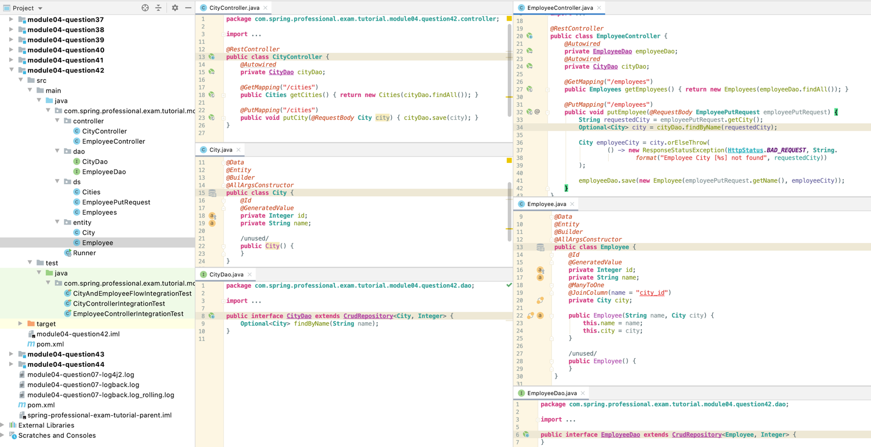

*@RunWith*(**SpringRunner**.**class**)  
*@WebMvcTest // will create all the controllers used in the project***public class CityAndEmployeeFlowIntegrationTest** {  
 *@Autowired* **private MockMvc** mvc;  
 *@MockBean* **private CityDao** cityDao;  
 *@MockBean* **private EmployeeDao** employeeDao;  
  
 *@Test* **public void** shouldSaveCitiesAndEmployees() **throws Exception** {  
 mvc.perform(  
 *put*("/cities")  
 .content("{ \"name\": \"New York\" }")  
 .contentType(**MediaType**.***APPLICATION_JSON***)  
 ).andExpect(*status*().isOk());  
  
 mvc.perform(  
 *put*("/cities")  
 .content("{ \"name\": \"Los Angeles\" }")  
 .contentType(**MediaType**.***APPLICATION_JSON***)  
 ).andExpect(*status*().isOk());  
  
 *when*(cityDao.findByName(***NEW_YORK_NAME***)).thenReturn(**Optional**.*of*(***NEW_YORK***));  
 *when*(cityDao.findByName(***LOS_ANGELES_NAME***)).thenReturn(**Optional**.*of*(***LOS_ANGELES***));  
  
 mvc.perform(  
 *put*("/employees")  
 .content("{ \"name\": \"John\", \"city\": \"New York\" }")  
 .contentType(**MediaType**.***APPLICATION_JSON***)  
 ).andExpect(*status*().isOk());  
  
 mvc.perform(  
 *put*("/employees")  
 .content("{ \"name\": \"Dave\", \"city\": \"Los Angeles\" }")  
 .contentType(**MediaType**.***APPLICATION_JSON***)  
 ).andExpect(*status*().isOk());  
  
 *verify*(cityDao).save(**City**.*builder*().name(***NEW_YORK_NAME***).build());  
 *verify*(cityDao).save(**City**.*builder*().name(***LOS_ANGELES_NAME***).build());  
 *verify*(employeeDao).save(**new** Employee("John", ***NEW_YORK***));  
 *verify*(employeeDao).save(**new** Employee("Dave", ***LOS_ANGELES***));  
 }  
  
 **private static final String *NEW_YORK_NAME*** = "New York";  
 **private static final String *LOS_ANGELES_NAME*** = "Los Angeles";  
 **private static final City *NEW_YORK*** = **new** City(1, ***NEW_YORK_NAME***);  
 **private static final City *LOS_ANGELES*** = **new** City(2, ***LOS_ANGELES_NAME***);  
}

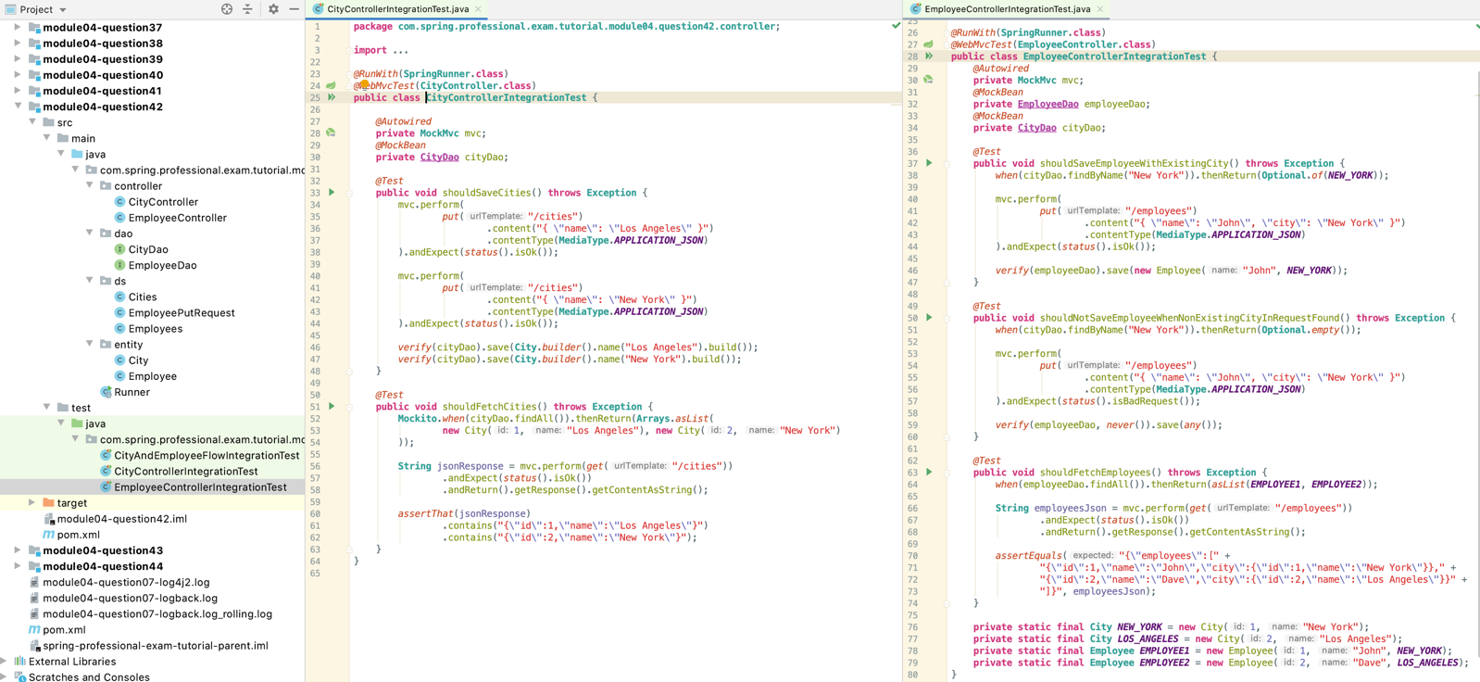

# Question 43-What are the differences between @MockBeanand @Mock?

@Mock annotation comes from Mockito Framework which allows for easy Mock creation. This annotation is used by MockitoJUnitRunner, each field annotated with it will have Mock for specified class created. This annotation does not inject mocks into tested class on itself, to use injection you need to have target class annotated with @InjectMocksannotation.

@MockBeanannotation comes from spring-boot-test, it creates Mockito Mock and also injects it into Application Context created by @SpringBootTest. All beans which refers to mocked class via @Autowiredwill get this mock injected instead of real class.

Main difference between @MockBeanand @Mock annotation is that @MockBeancreates mock and **injects it into Application Context**, while @Mock annotation **only creates it**, if you want to inject it, you can do it manually or with @InjectMocksannotation, however injection is being done **to the class not whole Application Contex**t.

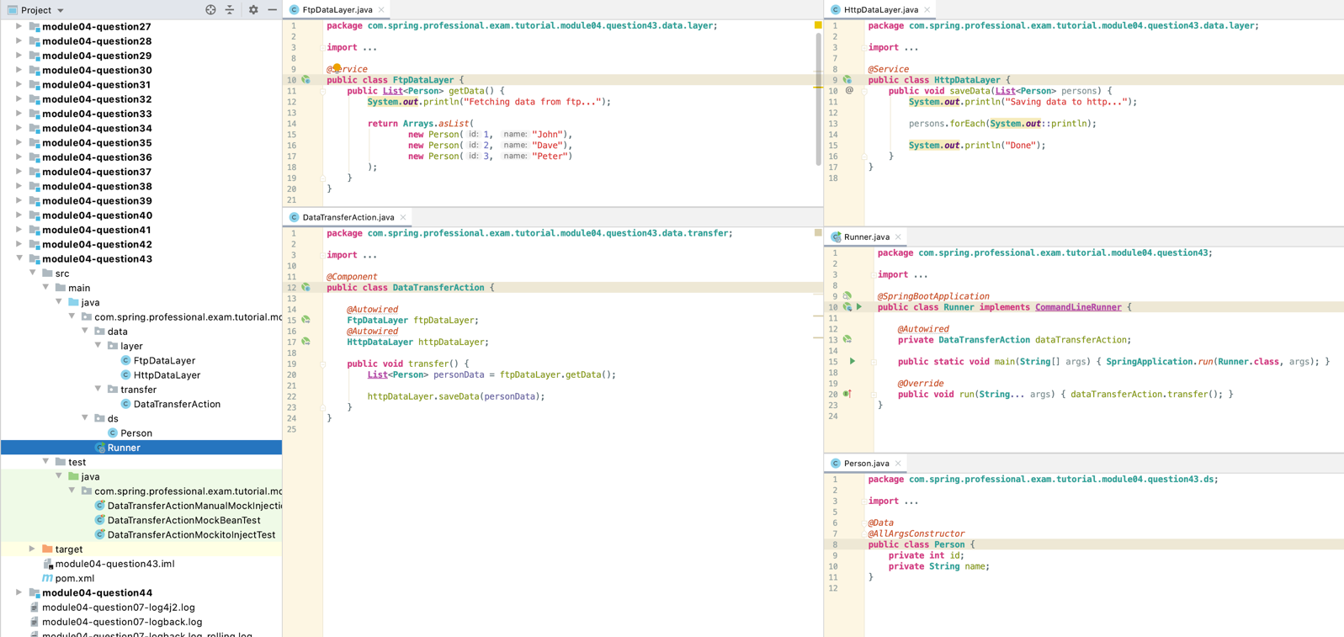

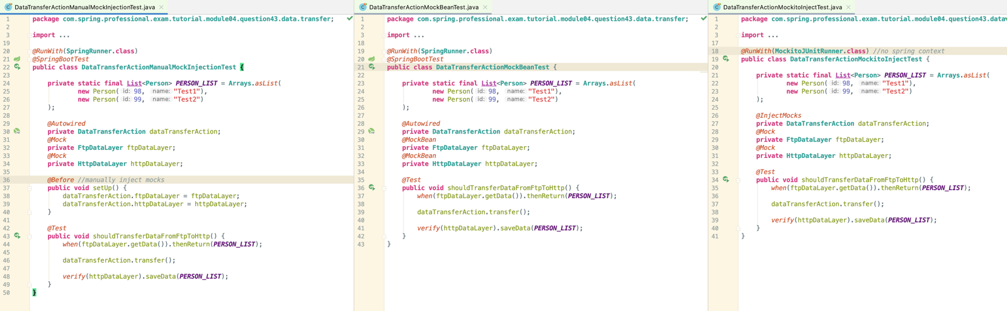

# Question 44 -When do you want use @DataJpaTestfor? What does it auto-configure?

You want to use @DataJpaTestannotation whenever writing an Integration Test for JPA related components of your application like Entities or Repositories.

@DataJpaTestannotation configures:

* In-memory embedded database –behaviour can be disabled with @AutoConfigureTestDatabase(replace = Replace.NONE)
* Scans and configures @Entitybeans
* Scans and configures Spring Data Repositories
* Configures TestEntityManager
* Does not load other components like @Component, @Service, @Controller etc.

Every @DataJpaTest is transactional by default, after each test transaction is rolled back. You can use @Transactional annotation to customize this behaviour.

When using @DataJpaTestyou can access TestEntityManager, which contains subset of EntityManager methods that are useful for testing.

